Spring 1 | Y3 Place Value and number knowledge to 1000
By the end of the teaching sequence children should… | Examples and models and images to use
Key concepts for Place Value
All place value should be taught through the following for the applicable numbers:
PV chart with dienes and from Y4 PV counters and dienes
Children should show a number with dienes and from Y4 PV counters and dienes
Show numbers on an ENL and a demarcated number line
Show numbers on a gattengno chart
Partition numbers by place value
Partition numbers in a variety of ways
Show partitioning with part whole models (bar and circle)
Order and compare numbers using images and a number line and verbal reasoning
Read and write numbers
Know there are 10 tens in a 100 and 10 hundreds in 1000 | 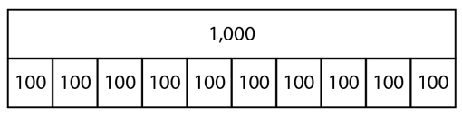  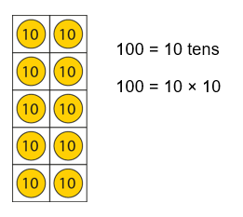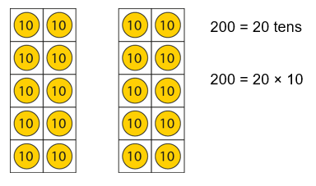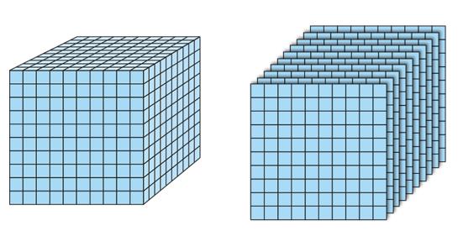  Draw links with unitising.
Count in 100s to 1000 NCETM 1.18 | 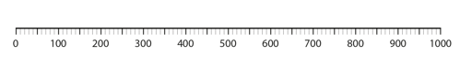  Also link with familiar counting such as counting in twos and 5s and 10s crossing 100bariiers  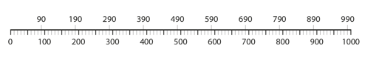
Represent numbers to 1000 and partition numbers to 1000 in a PV chart and part whole model NCETM 1.18 | 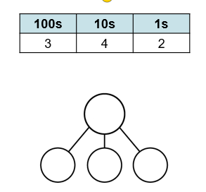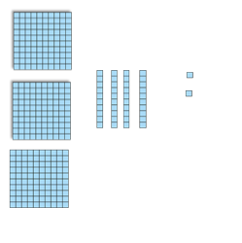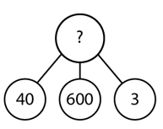
Partition numbers to 1000 in a variety of ways including unitising NCETM 1.18 | 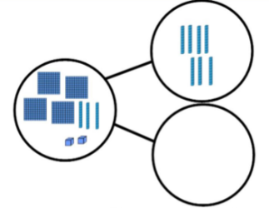  647 = 64 tens and 7 ones 647 = 63 tens and 17 ones  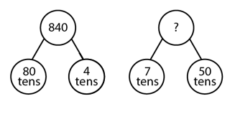  Give children plenty of opportunity to play with this concept using concrete apparatus
Order numbers to 1000
Read and write numbers to 1000
Count in and recognise multiples of 50 NCETM 1.18 | 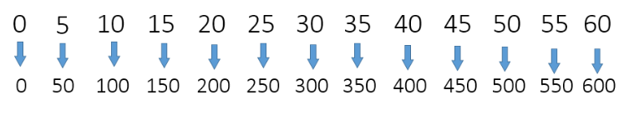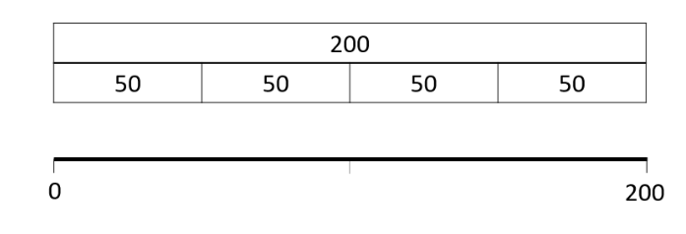
Place any number to 1000 on a numberline with 100s  NCETM 1.18 | 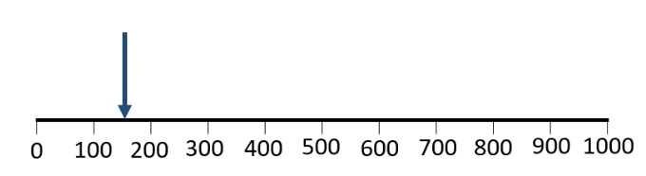
Place any number to 1000 on an ENL NCETM 1.18 | 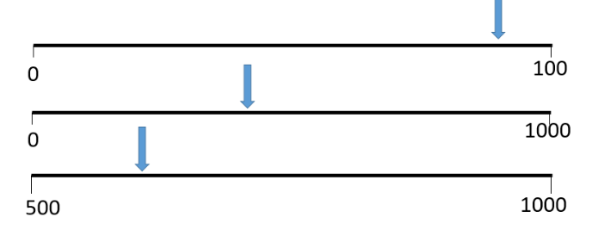
Know 1/ 10/ 100 more/less than any number to 1000 | 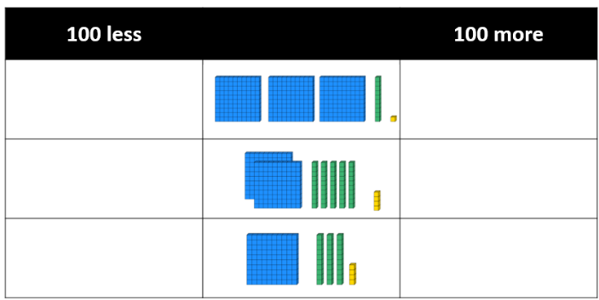
Compare numbers to 1000 using < > = | 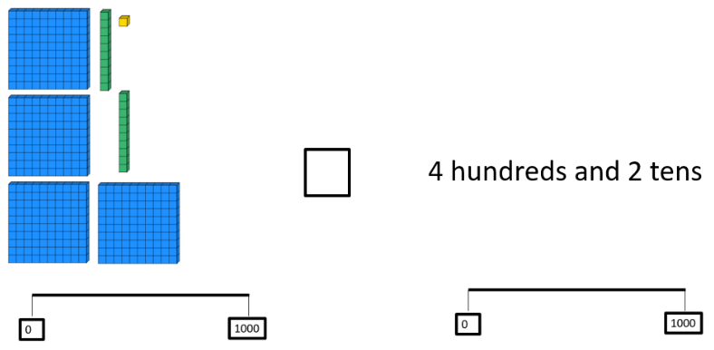
Spring 1 | Y3 Addition and Subtraction
Key concepts | Key Concepts for addition and subtraction  Language used must cover sum, difference, total, difference, altogether, how many more, how many less  Using part whole models to show inverse calculations and solve empty box calculations  Addition is commutative and subtraction is not  Use the associative law when adding 3 numbers to make calculations easier  Be able decide if a calculation is no work, mental, needs jottings or a written method and decide which is most efficient  Be able to adjust calculations to make them easier  Use estimation before calculating  Be fluent with ENL strategies  Understand finding the difference as a strategy and use adding on  Be exposed to problems with time, money and measure  Be exposed to problems with statistics such as reading graphs.
By the end of the teaching sequence children should… | Examples and models and images to use
Add and subtract multiples of 100 | 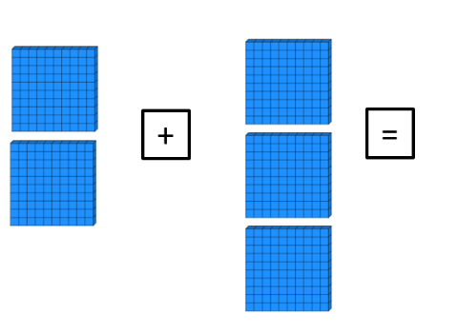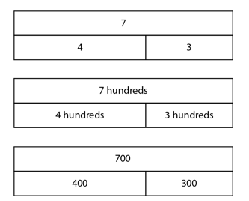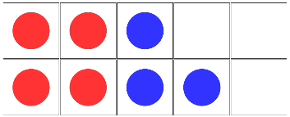
Number bonds to 1000 – 100s | 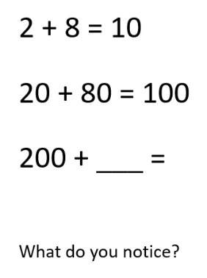  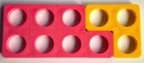  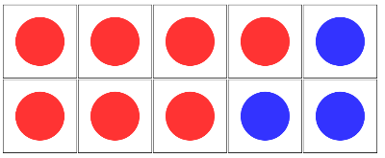  Use the same image as  Number bonds to 10
Add/subtract ones to/from 3d numbers to hitting multiples of 100 | 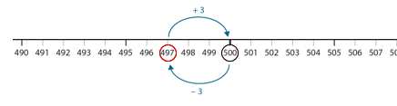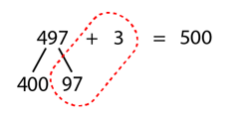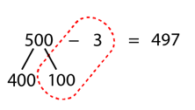
Add/subtract ones to/from 3d numbers crossing 10s and 100s | 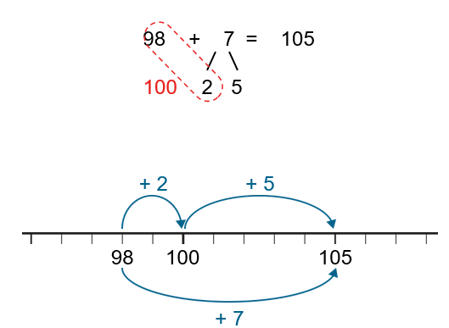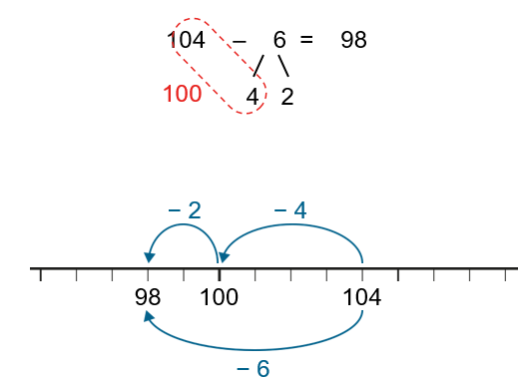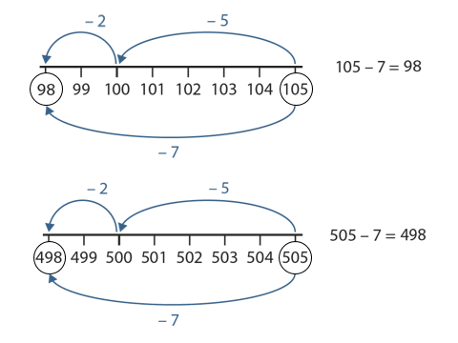
Add/subtract tens to/from 3d numbers to hitting multiples of 100 | 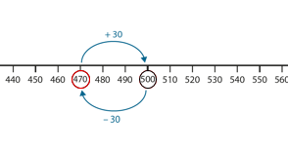  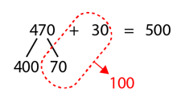  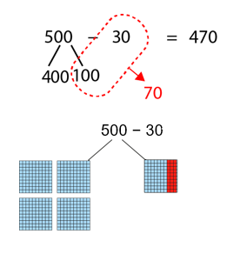
Add/subtract tens to/from 3d numbers crossing 100s  NCETM 1.18 | 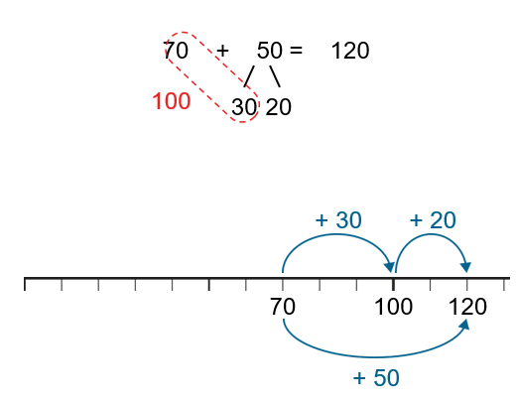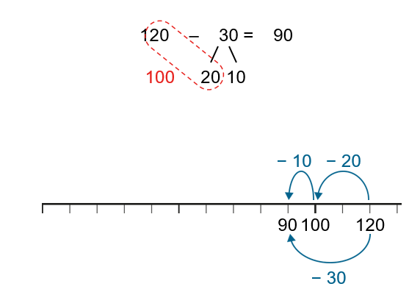  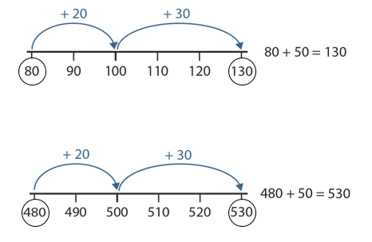
Add/subtract hundreds to/from 3d numbers | 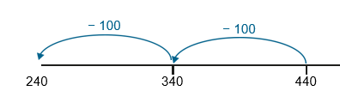
Add/subtract 2d to/from 3d numbers using ENL strategies  Counting in 10s, over jumping and hitting 10s. | 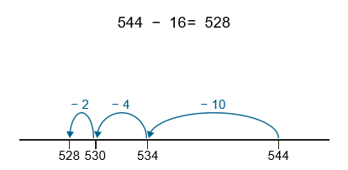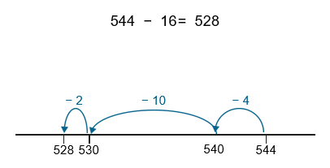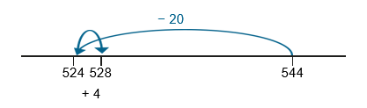
Add/subtract 3d to/from 3d numbers using ENL strategies | Over jumping  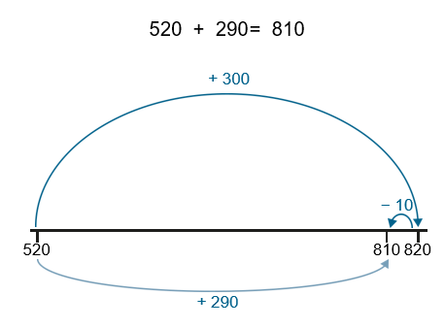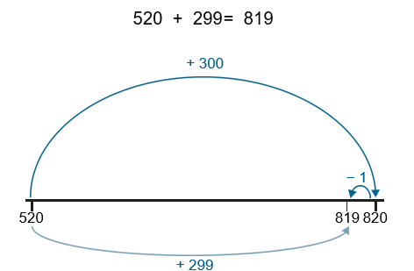  Jumping in hundreds, tens and ones  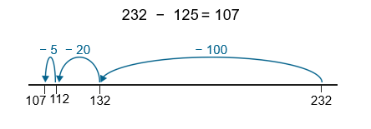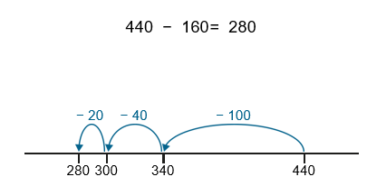
Use finding the difference / adding on for numbers which are close together | 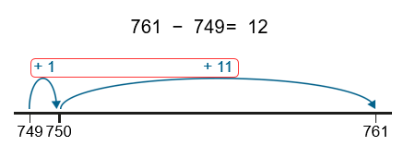
Use bar model and part whole models to create inverse calculations | 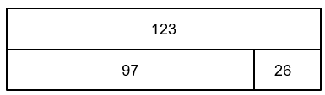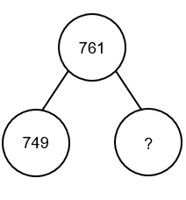
Spring 2 | Y3 Multiplication and Division
Notes | Times tables should be taught in addition to normal maths lessons and be part of continuous provision. Children should be fluent by now on 3s, 4s and 8s as well as their 2s, 5s and 10s . Refer back to key concepts at all times.
By the end of the teaching sequence children should… | Examples and models and images to use
Use the distributive law to make a calculation easier and to show the addition/subtraction of multiples (repeated addition) NCETM 2.10. | 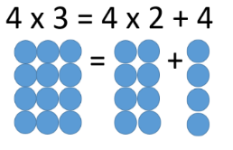  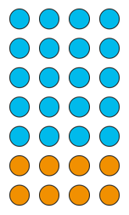  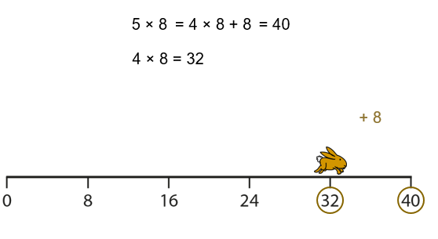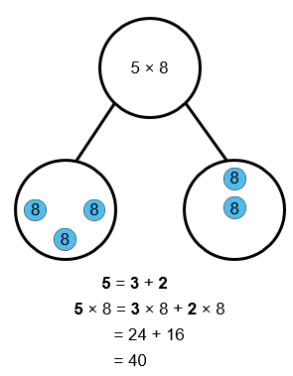  This part-whole is used later for multiplication and division  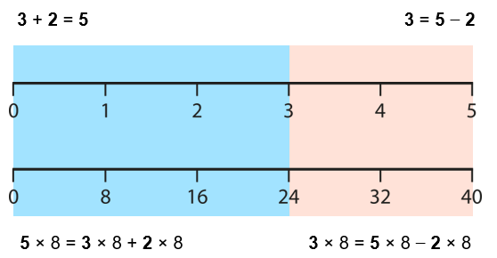
Multiply 1d by 10 and make the link with scaling | 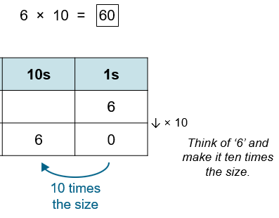  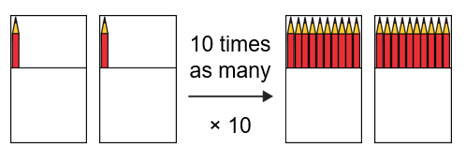  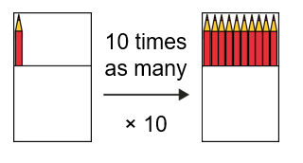
Multiply a multiple of 10 by 1d number and make the link with place value and scaling 2 x 6 = 12 2 x 60 = 120 3 x 5 = 15 30 x 5 = 150. This is key for the next step. | 12  3 3 3 3  120  30 30 30 30  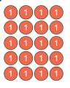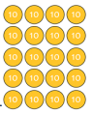  40 x 5 = 200 Can use coins as well as PV counters  50 x 4 = 200  Each counter is 10 times the size. Misconception 40 x 50  4 x 5 = 20  5 x 4 = 20  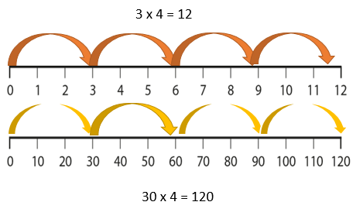
Use an array to multiply 2d by 1d | 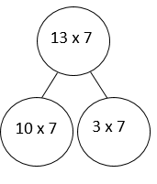  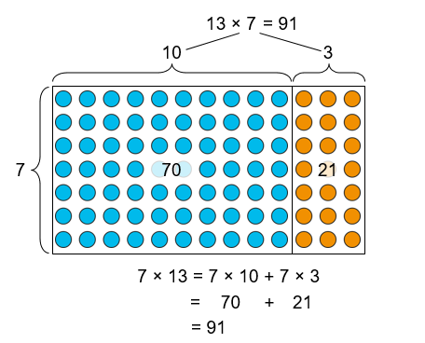
Use the area model/grid method to partition and multiply 2d numbers by 1d | 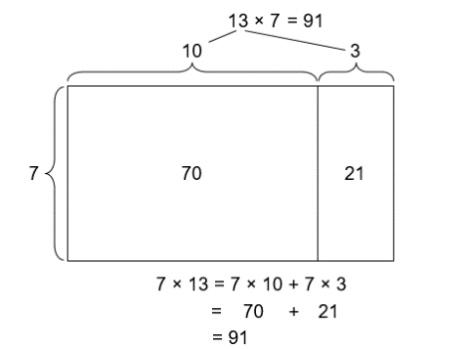  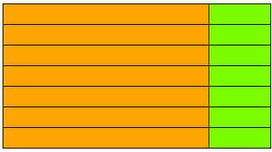
Choose an appropriate method to x 2d by 1d and discuss which is the most efficient and why 36 x 2 (double) 23 x 4 – (double then double again) 15 x 6 ( 15 x 3 = 45 so just double 45 ) 53 x 8 (area model)
Understand scaling and how it relates to multiplication  4 x bigger – word problems and bar model problems see White Rose | 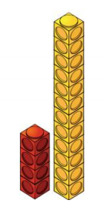  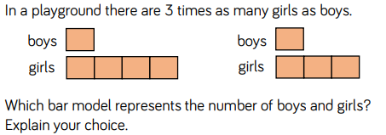
Understand correspondence problems 3 hats 4 coats – how many different outfits? See White Rose | 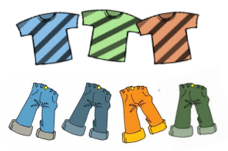
Divide using times table knowledge 72 ÷ 8 = 9 | 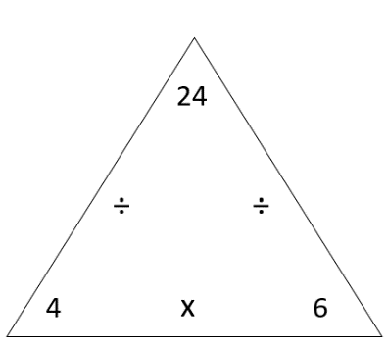  24 ÷ 4 = 6 24 ÷ 6 = 4  Also link back to fractions of an amount ¼ of 24 is 6
Divide 2d by 1d using place value knowledge 12 ÷ 3 = 4 so 120 ÷ 3 = 40. This is key for the next step. | 12  3 3 3 3  200 ÷ 4 =50  200 ÷ 5 = 40  20 ÷ 4 =5  20 ÷ 5 = 4  120  30 30 30 30  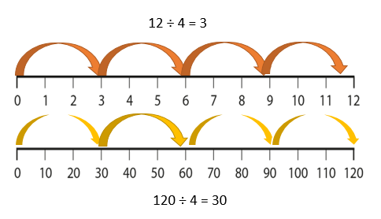
Divide 2d by 1d using concrete apparatus partitioning into tens and ones. | 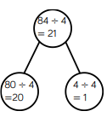  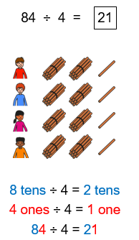  Like multiplication most 2d by 1d divisions can be solved a different way. E.g. this can easily be solved by halving and halving again. Whilst teaching this method maintain that discussion of different methods. Counting in 4s also a method but it is not efficient.  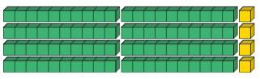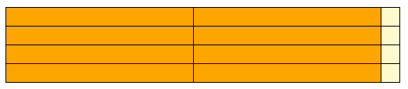  The same image can be shown with dienes and Cuisenaire to show inverse of the area model 21 x 4 = 84
Divide 2d by 1d using partitioning into known multiples of the divisor.  Use lots of practice with dienes. Some children may move on to a jottings version of this once the concept is secure. | 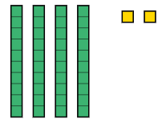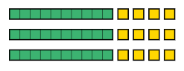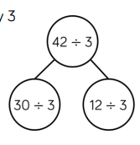  Exchange a ten for 12 ones  42 ÷ 3
Division with remainders NCETM 2.12  This really helps secure the concept of division so may be helpful at the beginning of the division unit. | 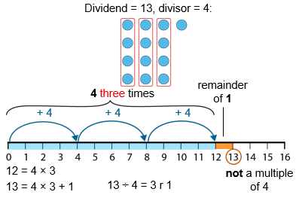  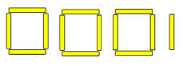  13 ÷ 4 making squares and triangles with lollipop sticks to show the concept of remainders . Move on to showing on a number line and array with concrete apparatus.

