Spring 1 | Y6 Ratio and Proportion
Notes | Children should have an understanding of what percentage is from Y5 and be able to recall the basic FDP equivalences (1/2 ¼ 1/5 1/10 ) both unit and non-unit.
By the end of the teaching sequence children should… | Examples and models and images to use | Notes
Recall and compare equivalent fractions, percentages and decimals | 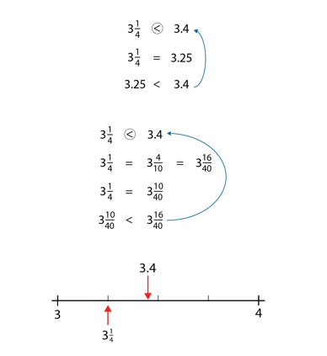  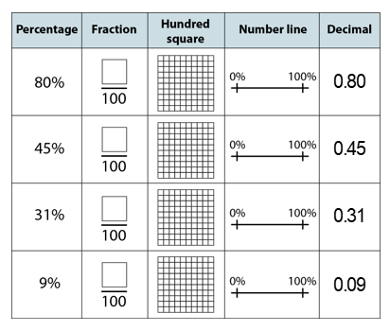  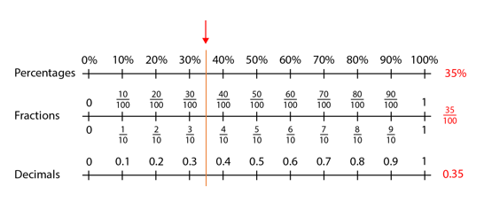 | NCETM 3.10 is a good reference point for this unit of work on FDP.  White Rose is also good for bar model images.
Understand fractions as division and use this to calculate decimal equivalents of fractions | ¾ is 3 ÷ 4 3/8 = 0.375 | Use tenths as an example of how this work 1 ÷10 = 0.1 or 1/10 of 1
Use FDP in contexts | 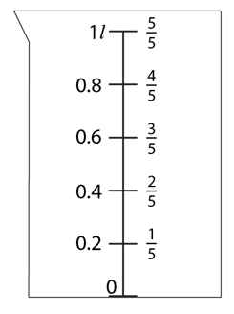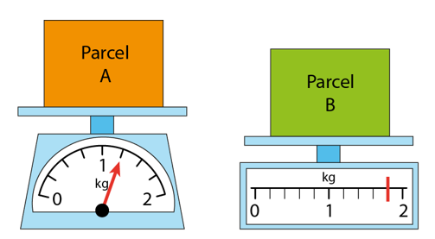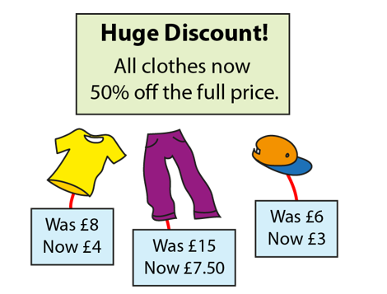 | Review measures and money
Find % of an amount | 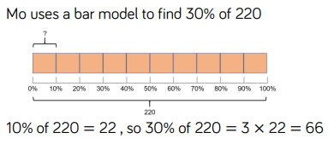 | Review fractions of an amount. Use the image of the bar model which the children are familiar with. Practise finding 5% by dividing 10% by 2 and 1% by dividing by 100.  Find 99% by subtracting 1% etc.
Find the whole from a % | 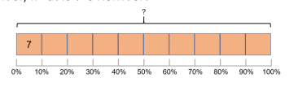  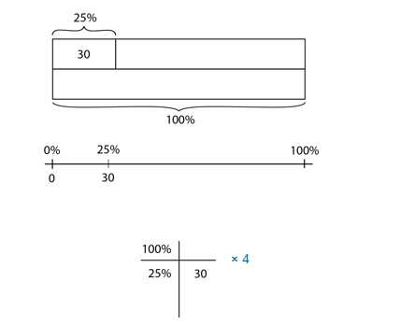  If 25% of my number is 30 – how much is my whole amount. | Children should be familiar with this skill from fractions of amount. Using the fraction to find the whole.
See ratio as a relationship between 2 values | 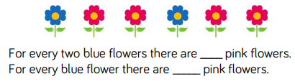 | Use cubes/counter for concrete resources. Give children plenty of opportunity to play with this new concept and talk about the relationship between the 2 numbers
Use the ratio symbol | 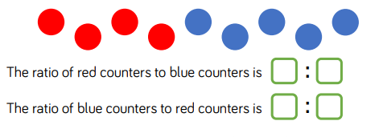
Show ratio in its simplest form and equivalent ratios | 1:2 4 : 1  2 : 4 8 : 2  3: 6 16 : 4 | Children should notice the relationship between the numbers and that the fractional amount will remain the same.
See ratio as fractions | 1 : 2  1/3 2/3  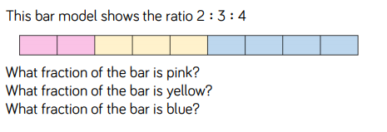 | Misconception alert! Children will often see 1:2 as ½ and need to see that there are 3 parts and therefore is 1/3 and 2/3. Again, as above, use concrete resources and plenty of time to play.
Compare 3 quantities with ratio | 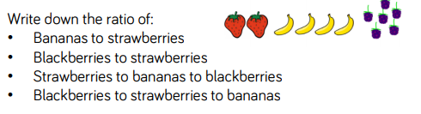
Calculate with ratio | 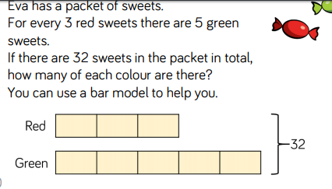  See the link with fractions and number of parts  32 | White Rose SOL and barvember has lots of ratio word problems.
 | Y6 Algebra
Notes | Children are familiar with algebra due to missing number problems and the formulae for area and volume therefore this needn’t be a big worry for children and it is the problem solving aspect that should be focussed on.
By the end of the teaching sequence children should… | Examples and models and images to use | Notes
Use simple formulae | 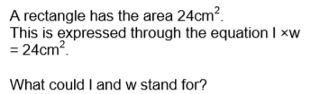 | Make sure children are aware that they have already used formulae for area and volume
Generate linear sequences with algebra | 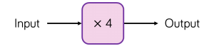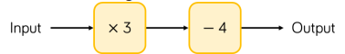 | White Rose has good progression on this
Express missing number problems algebraically | 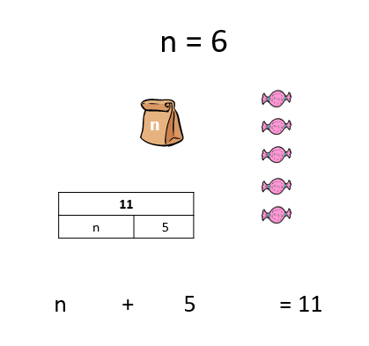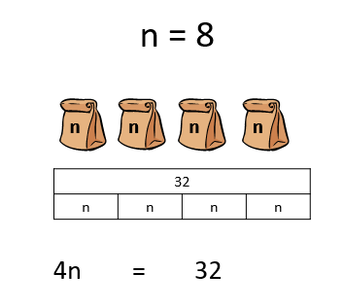  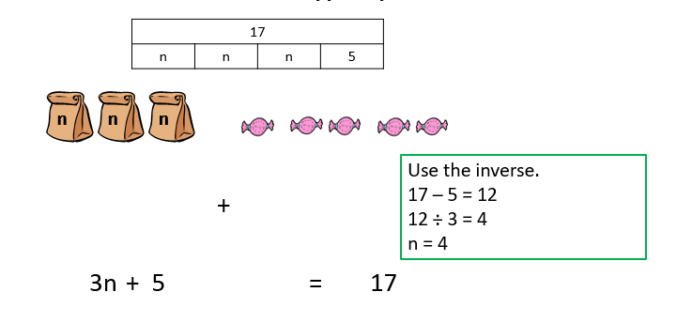 | Link to part whole models used further down the school
Solve find all possibility problems | 11  a b | NCETM 1.31
Find pairs of numbers that satisfy an equation with two unknowns | 10  g g w  Year 6 have earnt 200 stars; the stars are either gold or silver. They have 30 more gold stars than silver. How many are gold?  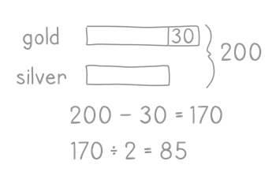  Anna and Ellen have £70 in total. Anna has £16 more than Ellen. How much money do they each have?  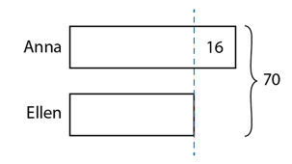 | NCETM 1.31
Spring 2 | Y6 Shape, angles and position
Notes | Geogebra is an excellent website for showing these images and being able to show if one angle changes how the others will too  https://www.geogebra.org/?lang=en-GB White Rose is also very good for images and reasoning
Teaching Points | Examples and models and images to use | Notes
Review angles and turns | 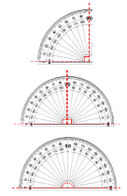 | Review turns in context of compass points, diving, skating and do turns than are more than one full turn e.g. 1 ¼ turn  Children should be clear on key facts 90 degrees in a right angle 4 right angles = 360 degrees and a full turn. Using 9 times table
Calculate missing angles on a straight line | 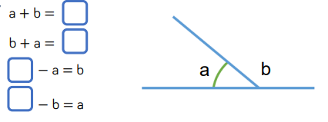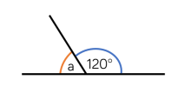 | Link to algebra and part whole models  Make sure the straight line isn’t always vertical or horizontal
Calculate vertically opposite angles | 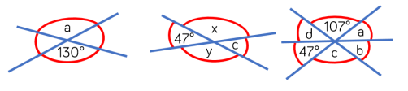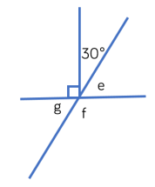 | Children should use their noticing skills to find the best way to calculate missing angels
Review properties of triangles |  | Make sure children are familiar with the 3 types of triangles
Find missing angles in a triangle | 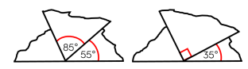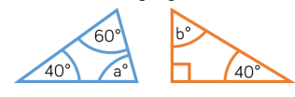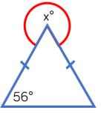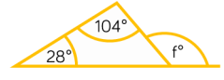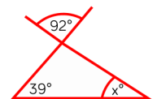 | Make triangles out of paper and tear up corners and put angles together to show that they make 180 degrees  Use different types of triangles
Review the properties of quadrilaterals
Find missing angles in a quadrilateral | 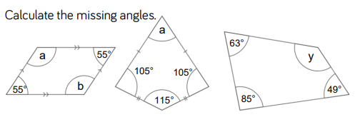 | Remind children of the rule of vertically opposite angles
Review properties of 2D shapes
Find missing angles in regular polygons | 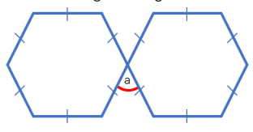 | Make sure children are exposed to the pattern spotting of the sum of the angles in polygons
Draw regular 2d shapes accurately |  | Check they can use a protractor correctly and a ruler!
Calculate scale factors | 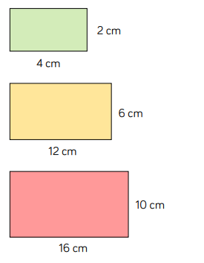  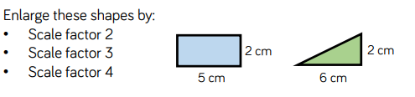  Enlargement has not been done in the same ratio for the pink rectangle so is not an enlargement of the green rectangle but the orange is | Children should be familiar with the language of scale factor – making something 10 times bigger linking to times tables. Also reviews ratio and gives lots of practise drawing of 2D shapes
Draw nets of 3D shapes | 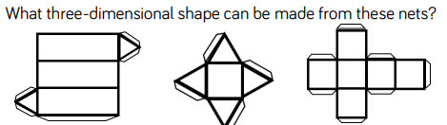 | Get cereal boxes etc and pull apart to see their net shape.
Understand that shapes with the same area can have different perimeters | 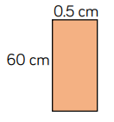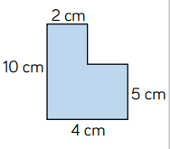 | Both shapes have an area of 30 cm².  Investigate how many different sides could an area of 24 cm²have. Review factors.
Use formulae for area and volume |  | Link to algebra
Calculate the area of parallelograms and triangles | 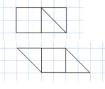  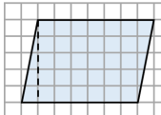  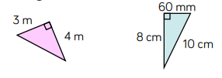  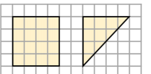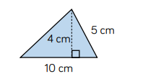 | Fold squares and rectangles into triangles to show that the area of a triangle is half. Use square paper to begin with so they can count the squares. Use right-angled triangles at first then move to the abstract formula base x height ÷2 for triangles.
Calculate, estimate and compare the volume of cubes and cuboids | 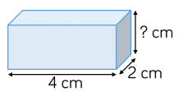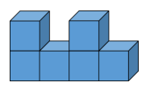  32 cm³ | Start with cubes first (could review cube numbers here). Give the volume then calculate the missing value.
Describe positions in all 4 –quadrants | 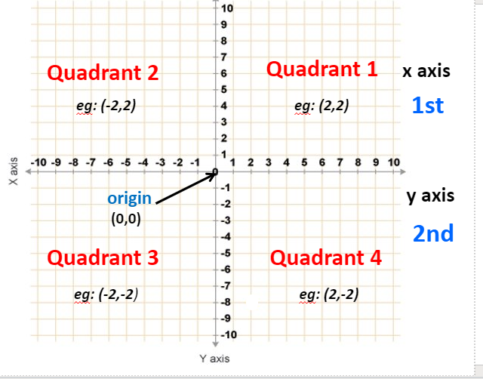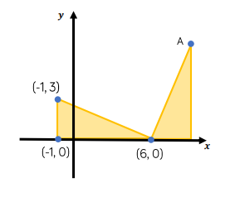 | Use laminated co-ordinates grids
Translate and reflect shapes through all 4 quadrants | 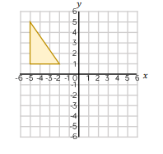 | Use paper 2D shapes , mirrors and a laminated co-ordinates grid for children to understand what is happening to the 2D shape.

