Autumn 1 | Y4 Place Value and addition and subtraction strategies
Notes | Recall facts document should also be used as continuous provision/ assessment to check children are secure on Y4 objectives. Previous CT should have noted any gaps on previous recall facts document
Autumn 1 | Y5 Place Value
Notes | Roman numerals should be taught as continuous provision not as a discrete lesson  Multiply and divide whole numbers by 10,100,1000 is part of multiplication and division but makes sense to put it here as you can use similar images such as the gattengo chart, place value chart, dienes and PV counters
By the end of the teaching sequence children should… | Examples and models and images to use
Key concepts for Place Value
All place value should be taught through the following for the applicable numbers:
PV chart with dienes and from Y4 PV counters and dienes
Children should show a number with dienes and from Y4 PV counters and dienes
Show numbers on an ENL and a demarcated number line
Show numbers on a gattengno chart
Partition numbers by place value
Partition numbers in a variety of ways
Show partitioning with part whole models (bar and circle)
Order and compare numbers using images and a number line and verbal reasoning
Read and write numbers
Know the place value of numbers to 1,000,000 and the value of each digit | 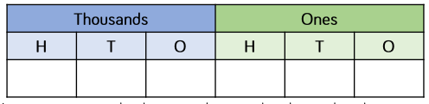  Use counters in PV chart- notice here how a PV chart is partitioned into ones, thousands, then millions  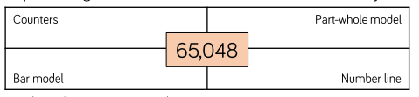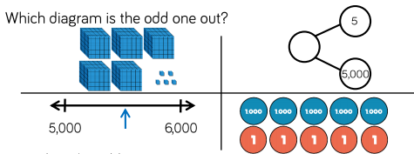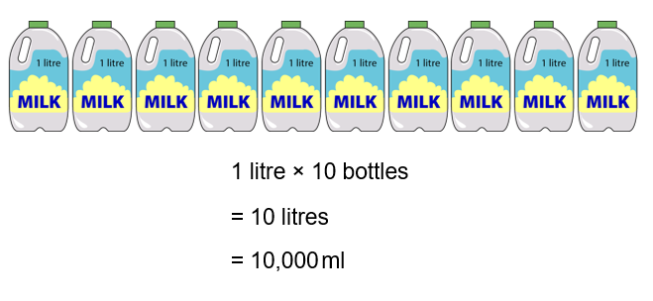  Make the link with measure
Represent numbers to 1,000,000 (This is a big jump from 10,000 to a million so may be best to do in stages)
Partition numbers to 1,000,000 in a PV chart 25, 647 = 2 ten thousands , 5 thousands 6 hundreds 4 tens and 7 ones 20,000 + 5000 + 600 + 40 + 7 | 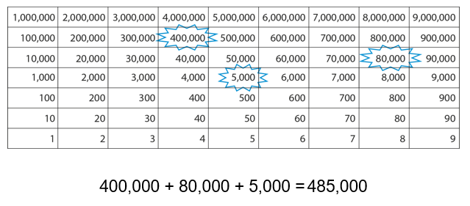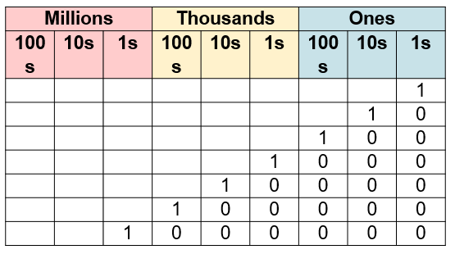
Partition numbers to 1, 000,000 in a variety of ways  25, 647 = 25 thousands, 64 tens and 7 ones or 15 000 + 10 000+ 300 + 300 +47 | 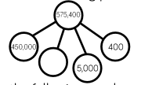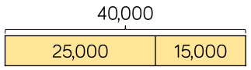  Introduce this concept with dienes as done in earlier years so children can see the numbers being split
Order numbers to 1,000,000 | 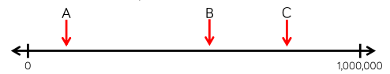
Read and write numbers to 1,000,000
Place any number to 1,000,000 on a numberline with 100,000s | 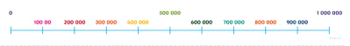 (this is from twinkl)
Place any number to 1,000,000 on an ENL
Count in tens forwards and back any number to 1,000,000 including crossing boundaries
Compare numbers to 1,000,000 using < > = | 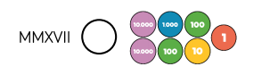
Multiply and divide whole numbers by 10,100,1000 | 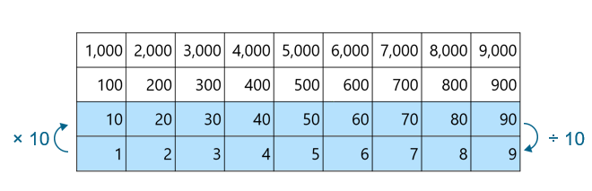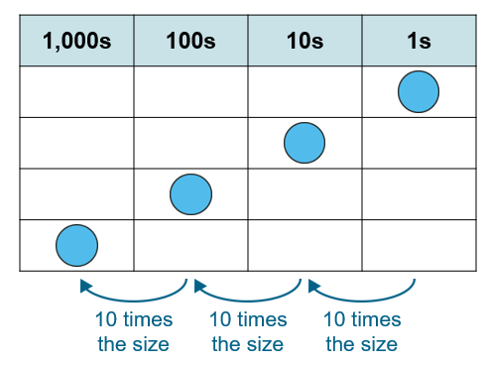  Part of multiplication and division but makes sense to put it here as uses similar images to place value work. Images taken from NCETM 2.13 (Y4) which is best for images to show this.
Use intelligent practice to apply multiplying and dividing by 10, 100 and 1000 | 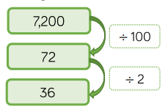  24 x 20  7200 ÷200
Show on a number line the nearest 10, 100, 1000, 10,000 and 100,000
Round any number to the nearest 10/ 100/1000/10,000 and 100,000 | 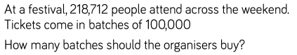  Word problems with rounding in context children must notice the context here  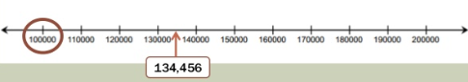  Graduate to using a ENL as well as looking at the digits
Autumn 1 | Y5 Addition and Subtraction
Notes | Key concepts  Use unitising language such as 5 tens subtract 3 tens equals 2 tens, three hundreds add 4 hundreds equals 7 hundreds.  Identifying no work, mental and jottings calculations should be part of continuous provision and once children are secure with written methods always provide calculations that don’t need a formal method. Empty box calculations, moving the equals sign and balancing equations should also be part of continuous practise and number talk.  Children should estimate their answer first  Multi step problems should be included including multiplication and division  Include problems with money and measure (keep previous year group objectives on the boil) and statistics (this block can be included with addition and subtraction)  ENL strategies should be used with time and can be practised with money and measure as well  Children should be able to adjust calculations to make them easier  Know that addition is commutative and subtraction is not  Be able to use the inverse to check (part whole models)  Vocabulary: sum, total, difference, total, altogether, how many more, how much less
By the end of the teaching sequence children should… | Examples and models and images to use
Add and subtract more than 4 digit numbers using PV counters to show exchanging | 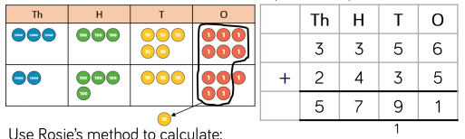  Use the language of uniting to explain. E.g 5 tens add 3 tens is 8 tens plus another one ten.  3 hundreds add 4 hundreds is 7 hundreds.etc.  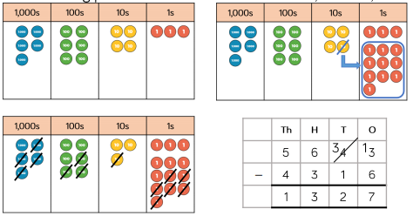
Add and subtract more than 4 digit numbers using the formal written method | 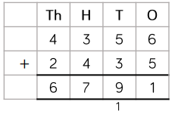  Extend children with deliberate mistakes and missing number calculations
Use rounding to estimate answers | Review rounding did earlier in the term or could move rounding numbers to here  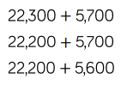
Be able to show negative numbers on a numberline
Count forward and back through 0 using negative numbers | 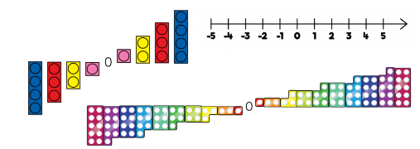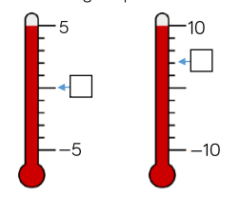
Autumn 2 | Y5 Statistics
Notes | This unit of work could easily be taught alongside the rounding, negative numbers and addition and subtraction strategies above rather than as a separate unit. Time should also be part of continuous provision.
By the end of the teaching sequence children should… | Examples and models and images to use | Notes
Read a timetable accurately and answer questions using ENL |  | Find real life timetables on the internet
Convert units of time (continuous provision)
Read line graphs and answers questions using ENL
Accurately create own line graph |  | Link to science
Autumn 2 | Y5 Multiplication and Division
Notes | Check children are fluent with all times tables to 12 x 12 and Y4 strategies Use recall facts document at the beginning of the year so any gaps can be filled before this unit. See Y4 Spring 1 for more info on written strategies that they should be confident with. NCETM 2 .21 for factors, primes and multiples
By the end of the teaching sequence children should… | Examples and models and images to use
Be able to multiply mentally or with jottings by partitioning in a variety of ways (revision of Y4) | 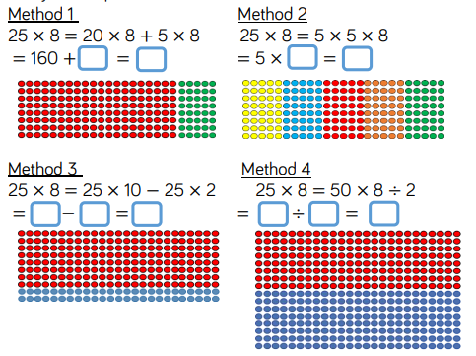  See Jo Boaler’s work on this.
Can divide mentally or with jottings by partitioning a number (revision of Y4) | 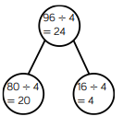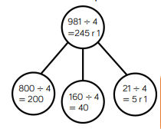
Can multiply and divide using known facts such as place value, times tables , doubling and halving the factors
Understand multiples and common multiples
Understand and find factors of a number – images from Y4 | 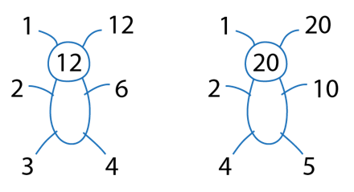  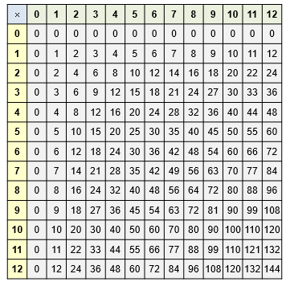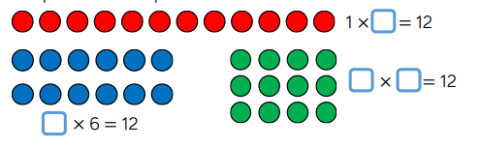  Make arrays using counters to find factors of the same product. Use x table square to make arrays
Understand and find common factors | 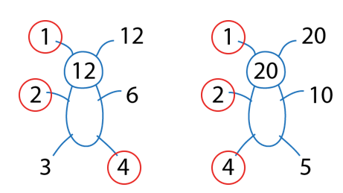  Teach children to be systematic by starting at 1 x then 2 x
Understand what a prime number is and re call prime numbers to 20 | 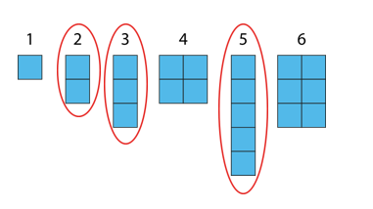  Can’t make an array with a prime number!
Understand what a composite number is | You can make an array with a composite number!
Can multiply and divide using factor and multiple knowledge | X 200 same as x 100 and x 2 x 500 same as x 1000 and dividing by 2  ÷ 200 the same as ÷ 100 then ÷ 2 see above
Create and complete extended multiplication and division facts | Fact triangle 4 x 6 = 24 40 x 6 = 240 4 x 60 = 24 40 x 60 = 2400 24 ÷ 6 = 4 240 ÷ 6 = 40 ¼ of 24 = 6 etc.
Understand and identify square numbers | 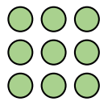  Make squares out of counters to show concept. | Volume and area will both be taught in more detail in the summer term but either make links here or teach together here. See NCETM 2.20 for volume and x 3 factors. See NCETM 2.16 for area and perimeter
Know all square numbers to 12 x 12 | 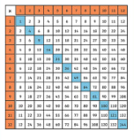  Use a multiplication grid to show square numbers making a square.
Understand and identify cube numbers | 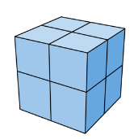  Make cubes out of multilink to show concept.

