Spring 1 | Y4 Multiplication and Division
By the end of the teaching sequence children should… | Examples and models and images to use | Notes
Have reviewed all the key concepts of multiplication and division (using applicable times tables in Y3 and Y4).  These will have been covered in Y3 (see Y3 for images) but need to be constantly reviewed and referred to. This can be done through number talk and arithmetic as well as being explicitly part of a lesson. | Key concepts:  Understand the concept of multiplying by 1 and by 0  Understand the concept of dividing by 1 and itself  Use fact triangles to make multiplication and division fact families and extended fact families  Understand multiplication as repeated addition  Understand multiplication and division as an array  Use the distributive law to make calculations easier 7 x 8 can be 5 x 8 + 2 x 8 (use arrays)NCETM 2.10  Understand that multiplication is commutative but division isn’t  Make links with doubling and halving (in Y3 and Y4 through links with 4 x and 8x and 3x and 6x and in UKS2 doubling and halving factors)  Be able to discuss which methods are efficient and error proof or error prone.  Be able to multiply 3 numbers  Use multiplication in the context of scaling ( 3 times as many, 10 times bigger problems )  Vocabulary:  Use group size and number of groups 3 , 4 times  Use the language of dividend ÷ divisor = quotient factor x factor = product  Understand and use the word multiple  Understand and use multiply, divide, groups of, lots of, grouping and sharing (quotitive and partitive division)  Use unitising language 30 x 4 3 tens, 4 times
Know all tables to 12 x 12 | Children should be secure on multiplication tables from Y2 and Y3 already through continuous provision and a separate practise. Children will know all times tables by the end of the Spring Term. Use NCETM 2.8, 2.9. and 2.11 for times tables as well applicable White Rose sections and cover the key concepts above.
Find factor pairs of a number and understand that factor pairs are commutative. Teach children to be systematic and start with one. | 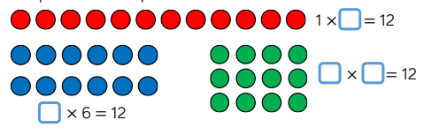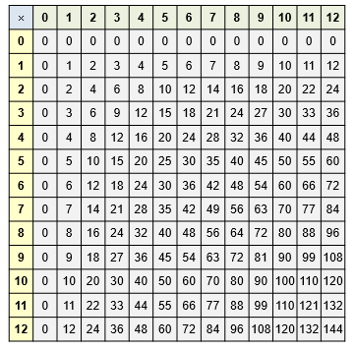  Make arrays using counters to find factors of the same product. Use x table square to make arrays  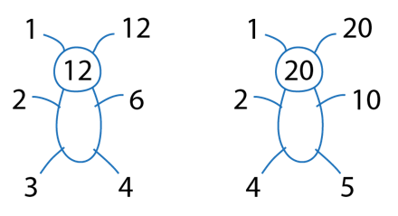  Possibility of teaching square numbers here (although Y5 objective) whilst making arrays for factor pairs.  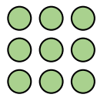
Use the associative law to make multiplying 3 digits easier | 2 x 16 x 5 can be 2 x 5 x 16 = 10 x 16 = 160
Multiply and divide by 10 and 100 NCETM 2.13 | 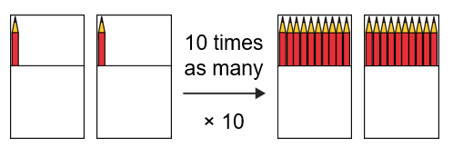  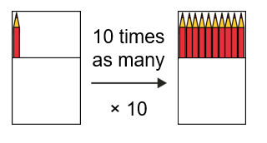  See Ncetm 2.13  Also use dienes here.  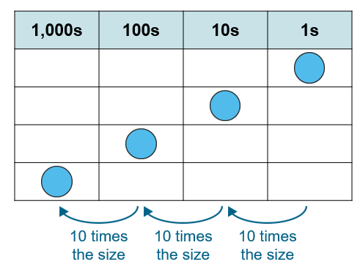  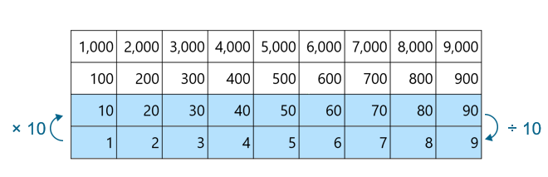  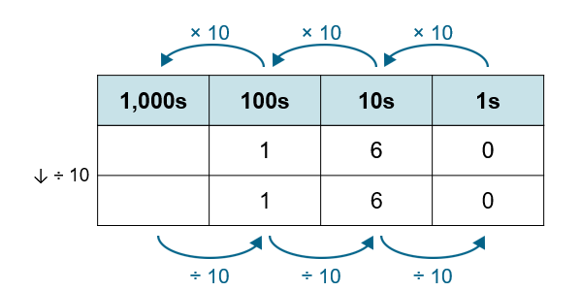  Also use dienes here with the PV chart before using PV counters and digits.  Links can be made with measure and money here.
Know that when you x by 100 you x by 10 and 10 again and vice versa for division
Know that x 5 is the same as x 10 then dividing by 2
Know that ÷ 5 is the same as ÷ 10 then x by 2
Use place value and known facts to multiply and divide  and create extended fact families using known facts | 120 ÷6 30 x 40 = 1200  6 x 4 = 240 60 x 4 = 240 60 x 40 = 2400 ¼ of 24 = 6 ¼ of 240 = 60
Multiply 2 d by 1d using the area model (reviewed from Y3) | 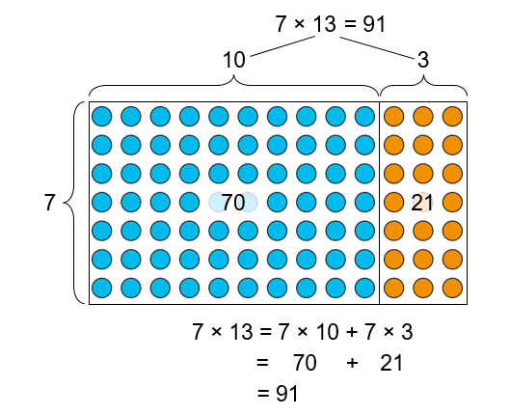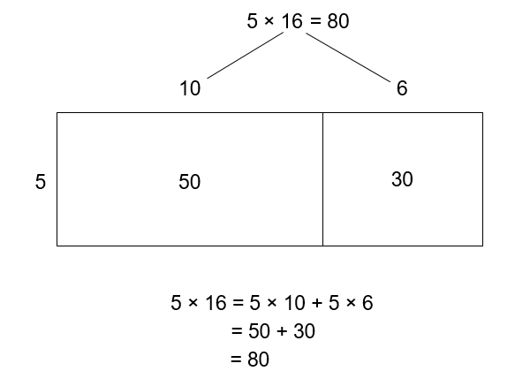  Cuisenaire rods can also be used see Y3.  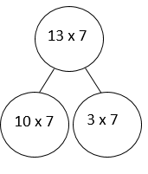
Multiply 2 d by 1d using short multiplication algorithm  (use the area model and algorithm alongside) | 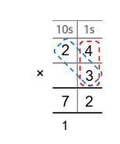  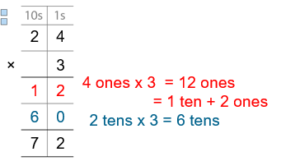  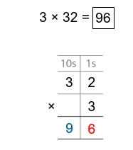  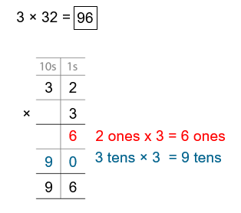  Expanded with area model alongside then abstract algorithm with area model alongside. Using language of unitising.
Multiply 3 d by 1d using the area model (possibly use formal method here as well – see Y5) | 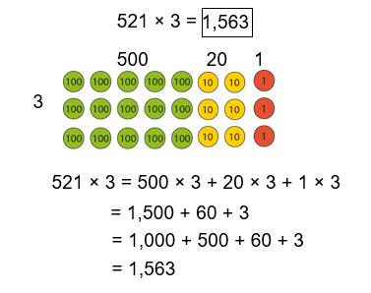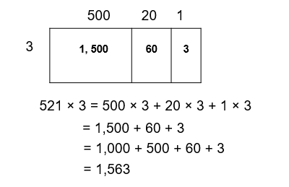
Solve correspondence problems using multiplication facts
Divide numbers using known facts and place value e.g using fact families | 640 ÷ 8 = 80 6400 ÷ 8 = 800 1/8 of 640  Division is always more difficult than multiplication so spend more time on it. Also link to fractions of an amount wherever possible.
Divide 2d by 1d using concrete apparatus and sharing. See NCETM 2.15 up to slide 41 for animations | 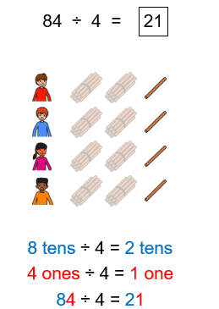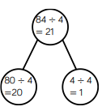  Different strategies should also be discussed. E.g. this could be solved by halving and halving again.  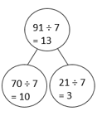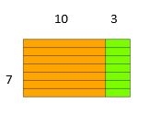  By using dienes and PV exchanging the tens for ones, children will learn to partition the dividend sensibly which in turn will help them move on to the mental/jotting strategy below.  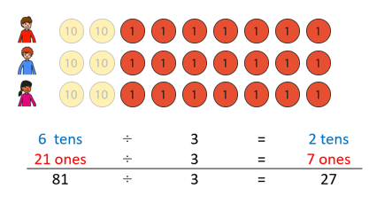  60 ÷ 3 =  21 ÷ 3 =  81 ÷ 3 =
Divide 2d by 1d using partitioning | 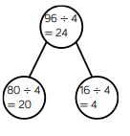  For many children once they have mastered the concept with the concrete apparatus (above) they can use this strategy as a mental/jotting strategy.
Divide 3d by 1d using concrete apparatus and sharing | 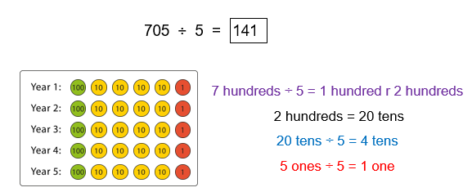  Dienes should be used before PV counters. Show exchanging of tens to ones. This model shows the groups of which leads on to short division in Y5.
Divide 3d by 1d using partitioning | 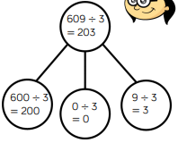  This should be used as an efficient mental/jotting strategy and a lead on to formal methods in Y5. If calculations are too complex then this method becomes inefficient and short division would be a more efficient method.
Divide with remainders see NCETM 2.12 and Y3 for a revision of this concept. | 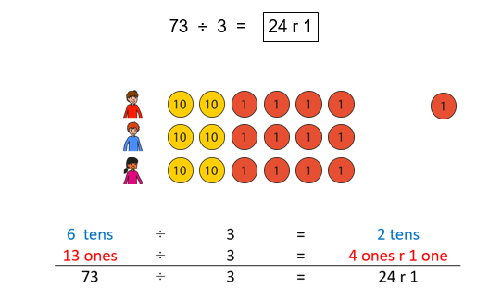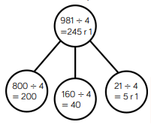
Spring 2 | Y4 Fractions
Notes | Before starting Y4 objectives review the key concepts from Y3. It is very important that all fraction work is done with concrete apparatus as well as diagrams and images.
By the end of the teaching sequence children should… | Examples and models and images to use
Have reviewed and be familiar with key concepts. | Key Concepts:  Understand unit and non-unit fractions and can represent them as diagrams, shapes, quantities and on a number line  Understand the concept of equal parts and the whole  Understand the language of numerator and denominator  That is the numerator and denominator are the same this makes the whole  That ½ means 1 whole divided by 2  When comparing unit fractions the greater the denominator the smaller the fraction  When comparing non-unit fractions with the same denominator the greater the numerator the greater the fraction.  From Y4 onwards:  Know that fractions can be equivalent and be able to show this with a diagram  Apply the knowledge of tenths and hundredths to money and measure  Vocabulary of improper fraction and mixed fraction
Represent equivalent fractions as images | 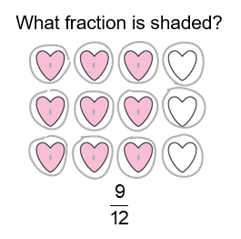 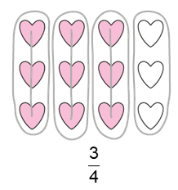 NCETM 3.3 step 2.6 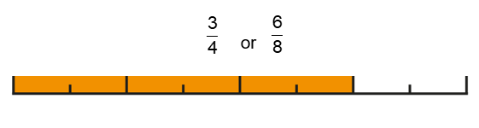
Find equivalent fractions making links with times tables (from Y3 objectives and Y4) | 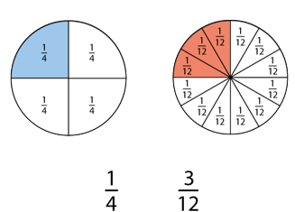  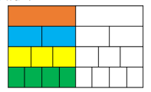  Use strips of paper and make own fraction wall then move to drawing and splitting up diagrams.  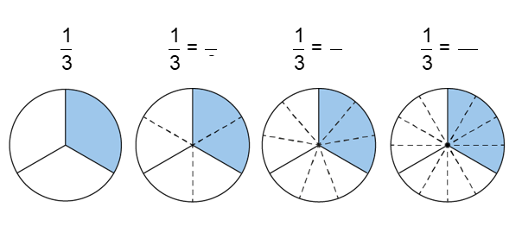  Draw attention to the multiplicative relationship between the fractions and the numerator and denominator. Children can then create their own from diagrams. Creating equivalent fractions in an abstract way will be in Y5
Know what fraction is need to complete the whole | 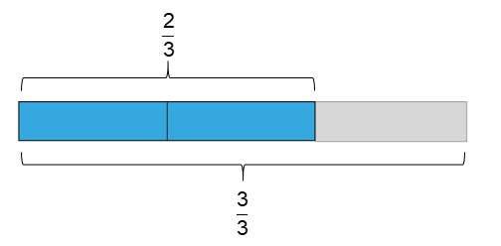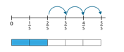
Count in fractions on a number line beyond a whole NCETM 3.5 | 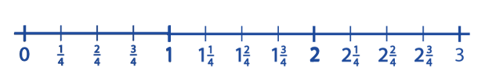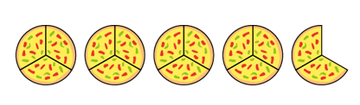
Show fractions of more than one as an image
NCETM 3.5
Understand the concept of improper fractions and mixed fractions and be able to represent a fraction both ways alongside an image | 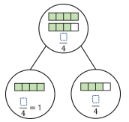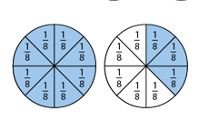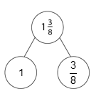
Add 2 or more fractions with the same denominator and show understanding with images | 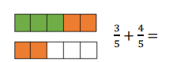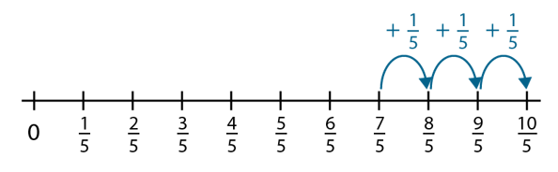  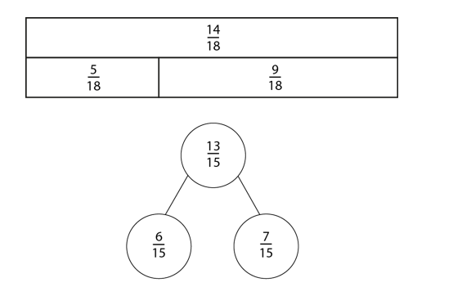  As in addition and subtraction for whole numbers use the part whole models and write the 4 equations.
Subtract 2 fractions with the same denominator and show understanding with images | 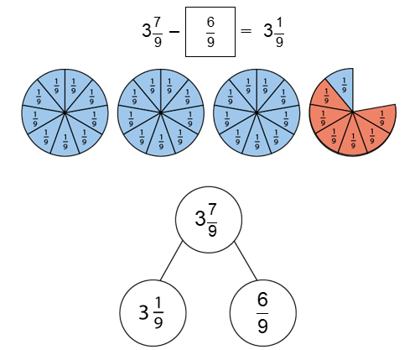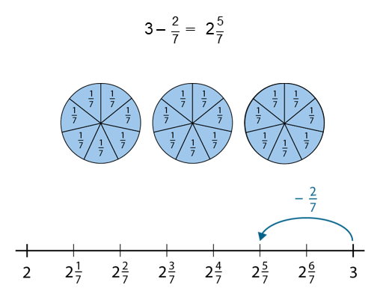  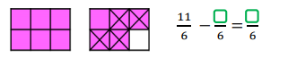
Find non-unit fractions of quantity review from Y3 and extend to larger numbers | 12  3 3 3 3  9  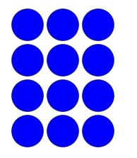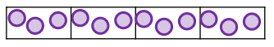
Find the whole from the fraction of quantity | Use the bar model to find whole amount from the fraction of the amount. If ¾ is 150ml how much is in the whole bottle  200ml  150ml 50ml

