Autumn 1 | Y5 Place Value and addition and subtraction strategies
By the end of the teaching sequence children should… | Examples and models and images to use | Notes
See Y5 Autumn 1 & 2 |  | Recall facts document should also be used as continuous provision/ assessment to check children are secure on Y5 objectives. Previous CT should have noted any gaps on previous recall facts document
Autumn 1 | Y6 Place Value
By the end of the teaching sequence children should… | Examples and models and images to use | Notes
Know the place value of numbers to 10,000,000 and the value of each digit | Use PV counters to model and place value chart  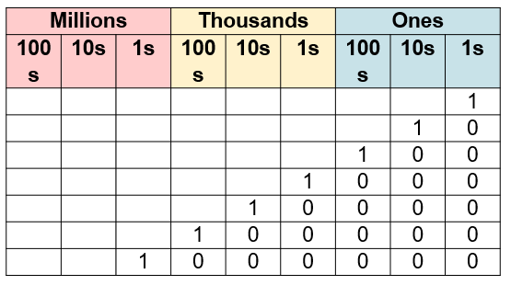 | Mix smaller and larger numbers .Although children need practise with larger numbers smaller numbers shouldn’t be forgotten
Represent numbers to 10,000,000 | 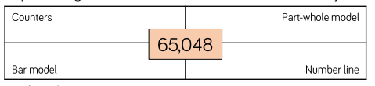  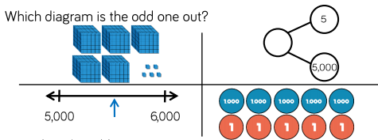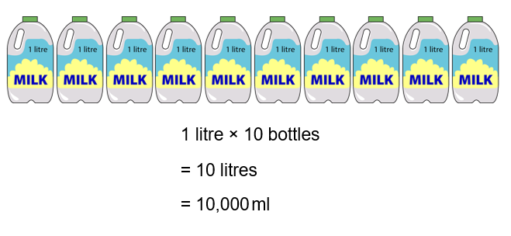 | Make the link with measure
Partition numbers to 10,000,000 in a PV chart | 25, 647 = 2 ten thousands , 5 thousands 6 hundreds 4 tens and 7 ones PV chart and counters 20,000 + 5000 + 600 + 40 + 7  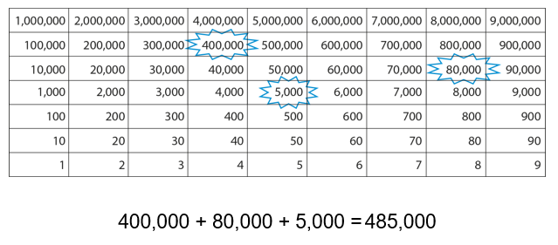
Partition numbers to 10, 000,000 in a variety of ways | 25, 647 = 25 thousands, 64 tens and 7 ones or 15 000 + 10 000+ 300 + 300 +47 PV counters  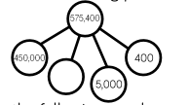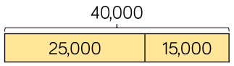 | Review partitioning in different ways from earlier years with dienes
Order numbers to 10,000,000 | 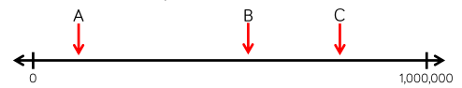 | Use number line and concrete apparatus for linear PV knowledge and columnar PV knowledge
Read and write numbers to 10,000,000
Place any number to 10,000,000 on a numberline with 100,000s | 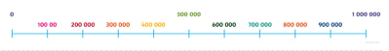
Place any number to 10,000,000 on an ENL
Compare numbers to 10,000,000 using < > = | PV chart and counters and ENL  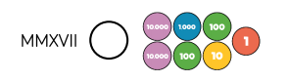
Multiply and divide whole numbers by 10,100,1000 | 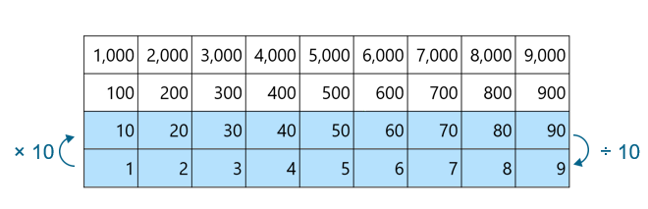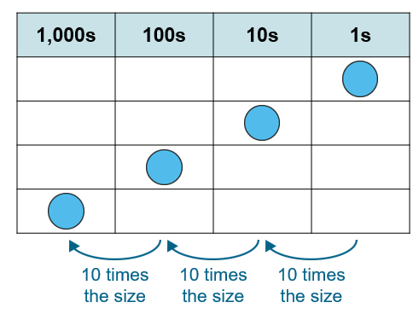 | Part of multiplication and division but makes sense to put it here as uses PV chart Images taken from NCETM 2.13 (Y4) which is best for images to show this.
Use intelligent practice to apply multiplying and dividing by 10, 100 and 1000 | 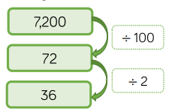
Round any number to the nearest 10/ 100/1000/10,000 and 100,000 | ENL - word problems – using rounding to estimate 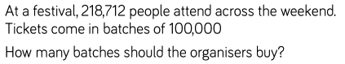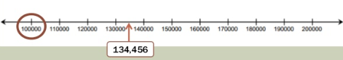 | Review below when calculating – using rounding to estimate
Read , write and order decimals to 3dp | See Y5 for decimals to 2 dp  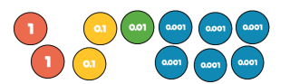  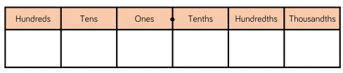  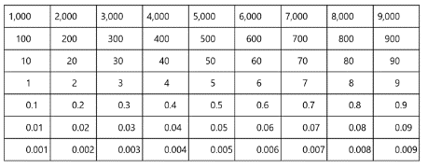  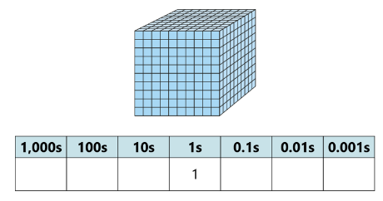 | Review fractions e.g tenths, hundredths
Autumn 1 | Y6 Four operations
By the end of the teaching sequence children should… | Examples and models and images to use | Notes
Solve problems using 4 operations and choose the most effective strategy including ENL strategies for time, termperature, money etc. | See Y3, 4 and 5 or each separate operation progression document (still to do June 2020) | Children should be fluent with the 4 operations by the end of Year 5. Review all strategies mental and written and use as chance review things such as time, measure, reading tables and fractions of amount and statistics see Y5
Divide 4d by 2d and interpret remainders as fractions and decimals | Use PV counters. Know that the denominator is the divisor and remainder is the numerator  147 ÷ 4 = 36 r 3 or 36. 75 or 36 and ¾ and can be solved in a variety of ways e.g mentally/ jottings using table knowledge or with PV counters  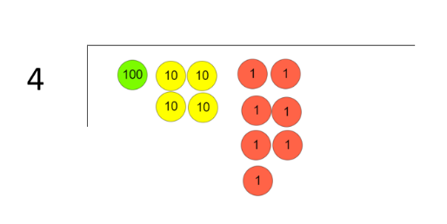  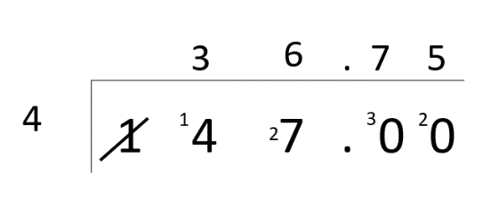  If know that ¾ = 0.75 don’t need to use formal method to find decimal equivalent. | Review of FD equivalence
Use short division to find fractions from decimals | 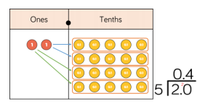  2/5 as a decimal | Concept of line between numerator and denominator meaning division introduced in Y3
Multiply and divide decimals by integers | 1.212 x 3 use grid method/ area model used with whole numbers  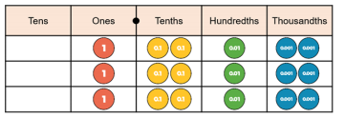  2. 34 x 5 = 11.7  x 2 0.3 0.04  5 10 1.5 0.2  6.39 ÷ 3  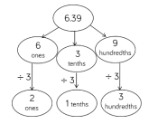 | Same as whole numbers use no work, mental, jottings and written. Don’t necessarily need written methods
Solve calculations which involve the 4 operations | 6 x 4 + 40 ÷ 10 General rule is that you read from left to right because x/ ÷and +/- are inverses of each other doesn’t really matter which order which is why the triangle works.  Triangle is more useful than BODMAS although BODMAS easier to remember!  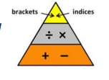
Use rounding to estimate answers | 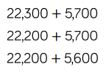
Identify a no work calculation, mental jottings and written |  | Across key stage
Be able to show negative numbers on a numberline | Use ENL  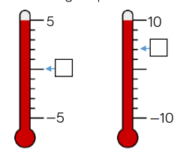 | From Y4 and Y5
Count forward and back through 0 using negative numbers
Calculate intervals across zero
Autumn 2 | Y6 Fractions
Notes | Review all of Y5 teaching on fractions
By the end of the teaching sequence children should… | Examples and models and images to use | Notes
Identify common factors and common multiples including lowest common factor and lowest common multiple. | Teach children to be systematic  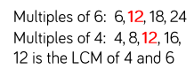  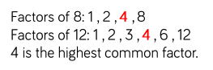 | Review factors, primes to 100, multiples Square no.s and cube no.s all Y5
Use common factors to simplify fractions | 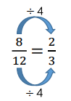  Simplify 8/12
Compare fractions by finding common denominators | When the denominators are the same, the greater the numerator the greater the fraction | Review comparing fractions with common denominators
Compare fractions by finding common numerators | When the numerators are the same, the smaller the denominator the greater the fraction | Review comparing fractions with common numerators
Put fractions on a numberline | 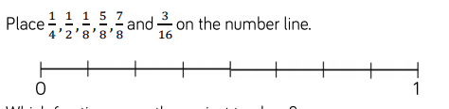 | Done across the Key Stage Y5/6 mixed denominators
Add and subtract fractions with different denominators and mixed numbers and give the answer in its simplest form | 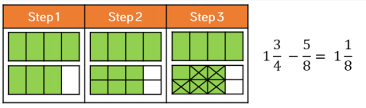  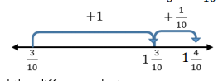  Find the difference between 3/10 and 1 2/5 1 2/5 = 1 4/10  Use ENL strategies  3 ¼ - 1 ¾ exchange one whole for 4/4 so 2 5/4 – 1 ¾  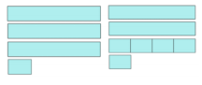  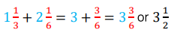 Adding wholes first then fractions. Empty box problems  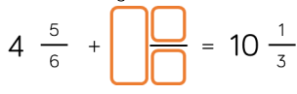 | Important as in adding and subtracting with whole numbers that children have a variety of strategies to fall back on and there is a discussion as to which is the most efficient. Also use same type of empty box and intelligent practise style questions you would use with whole numbers.  Fully review converting mixed and improper fractions from Y5 first.
Add and subtract 3 sets of fractions including mixed numbers and improper fractions | 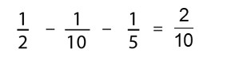
Multiply mixed numbers and fractions by whole numbers as repeated addition using visual images to demonstrate understanding | 7 x ¾ means ¾ 7 times  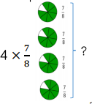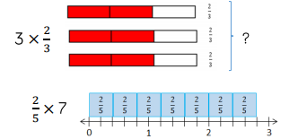
Multiply mixed numbers and fractions by whole numbers as part of a number and understand when this is more efficient | 100 x ¾ meaning ¾ of 100 = 75  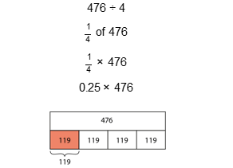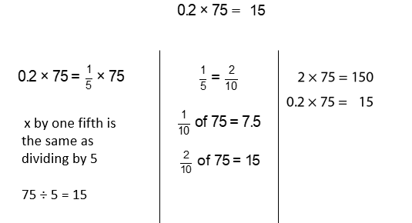  Review fractions of an amount
Multiple 2 sets of fractions using diagrams | 1/3 x ½ = 1/6  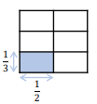 | Folding paper to find a half of a quarter ¼ x ½ = 1/8
Divide fractions by a whole number using diagrams | 1/3 ÷ 2 = 1/6 - important to note that the diagram is the same as above  So is the same as 1/3 x ½ = 1/6  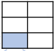  Also use equivalent fractions as another way to calculate 2/3 ÷ 4  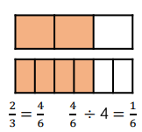 | Understand why dividing a fraction by 2 is the same as multiplying by a half  Also use folding paper activity in the same way ¼ ÷2 = 1/8

