Autumn 1 | Y2 Place Value and number knowledge to 100
Notes | Children should already be fluent in with Y2 objectives and recall facts.
By the end of the teaching sequence children should… | Examples and models and images to use
Know there are 10 ones in one 10 | 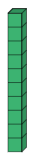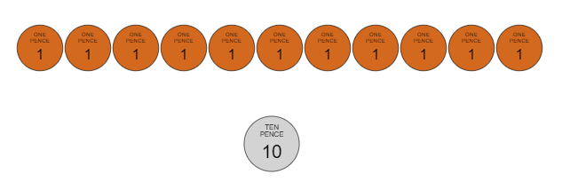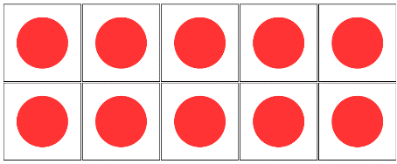
Number bonds to 10 | 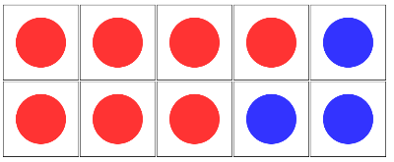  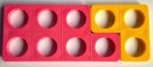  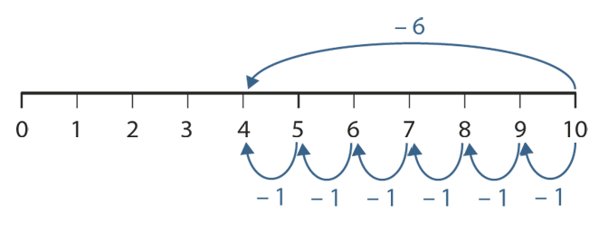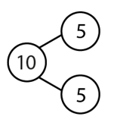  Use the part whole model and note the 4 calculations
Know there are 10 tens in a 100 | 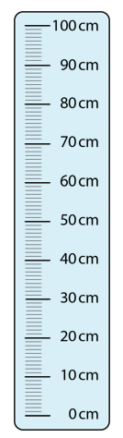  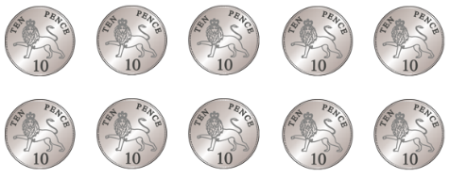  Children should be familiar with this concept using dienes so make the link with measures and money
Number bonds to 100 (multiples of 10) NCETM 1.17 | 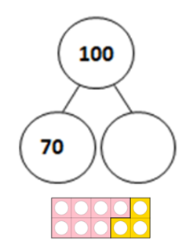  Links to measure metre rule  And use same image as number  Bonds to 10 except that each counter/ numicom tile is worth  10 times more  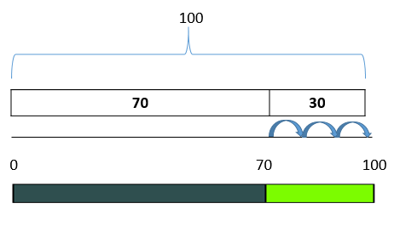  Introduce the idea of a numberline with the bar part whole model. Can use Cuisenaire as well.
Number bonds to 20 | 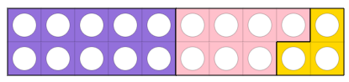  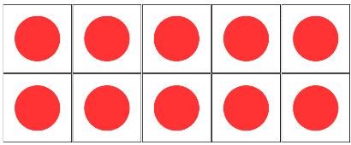  Use the tens frame and numicom to draw links with nb to 10  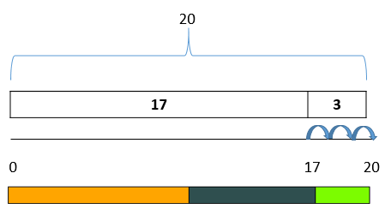  Introduce the idea of a numberline with the bar part whole model. Can use Cuisenaire as well.
Number splits to 20 NCETM 1.10 | 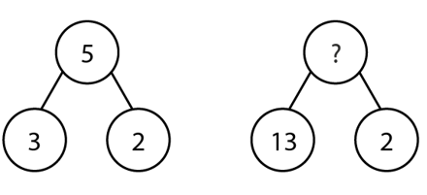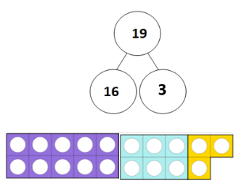  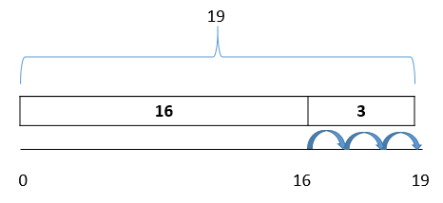  Making links with number splits and using ENL to show as well as numicom and tens frame as above.
Split any number to 99 into 10s and 1s and a variety of ways | 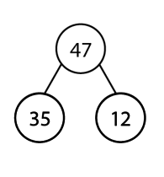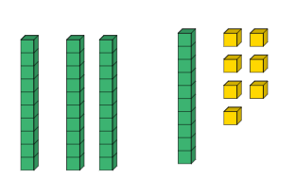  47 = 40 + 7 also 30 +17 35 + 12  Use dienes to split numbers and show on a number line as well. Give children lots of time to play with this idea as it will give them the skills to add and subtract using ENL.  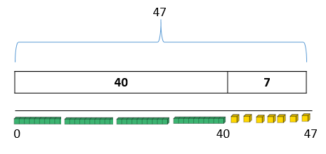
Add 3 one digit numbers efficiently (associative law) | 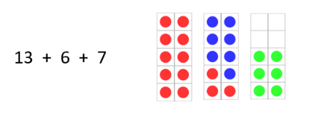  Noticing number bonds first
Understand that addition is commutative but subtraction isn’t
Plot numbers on an numberline with multiples of 10 | Very important that the language of multiples is used 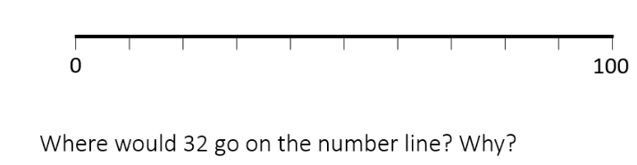
Plot any number on a ENL 1-100 | 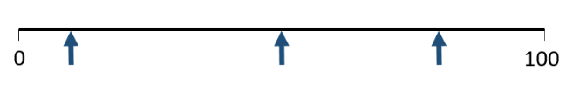
Number bonds to 100 – ones | 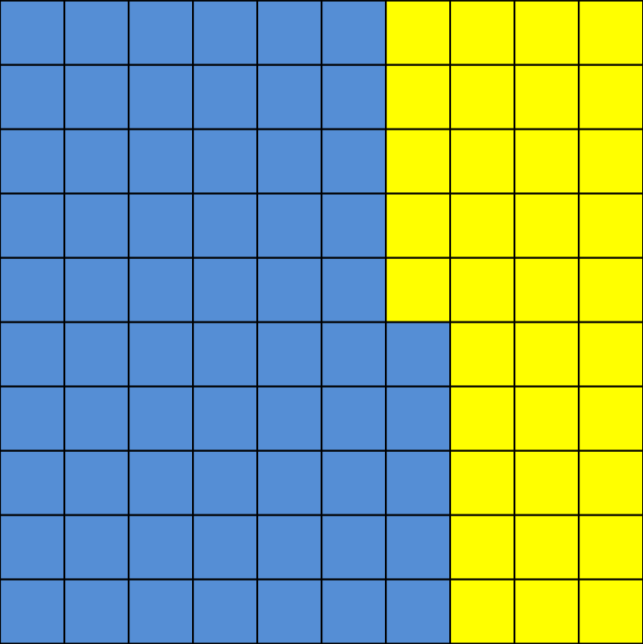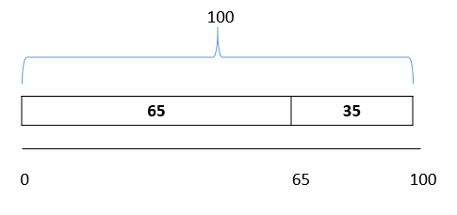  You could lay out the dienes along the numberline.  Misconception:  65 + 45 = 100  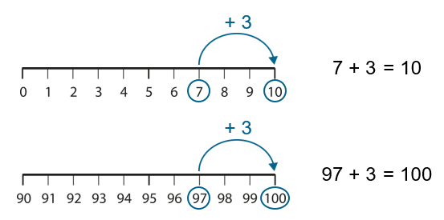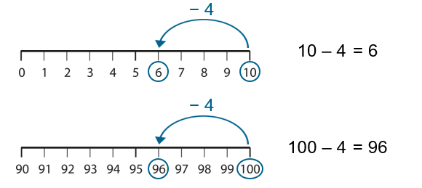
Know the next multiple of 10 from any number. | 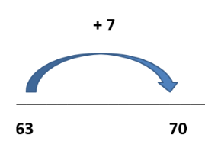  Make the link with nb to 10
Jump in multiples of 10 on ENL | 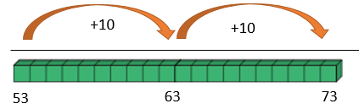  Put dienes alongside the numberline to help with conceptual understanding
Add/subtract one digit numbers NCETM 1.13
from any multiple of 10 | 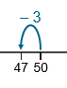  90 – 6 = 50 + 8 Make link to number bonds  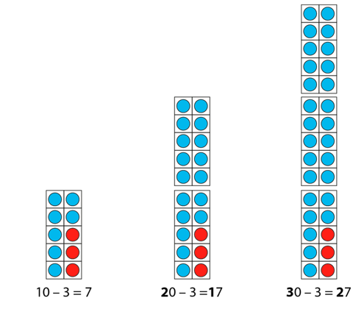
Add 1 d number to/ subtract 1 d number from any number using number splits/hitting 10s See NCETM 1.11 | 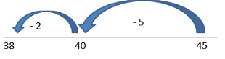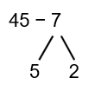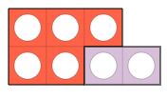
Add /subtract 7, 8 and 9 using overjumping | 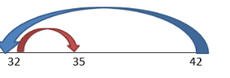  42 – 7
Add/ Subtract two digit numbers NCETM 1.14 1.15 1.19 | See Suffolk ENL strategy for more detail
Using jumping in multiples of 10 and number splits.  Over jumping  Adjusting | 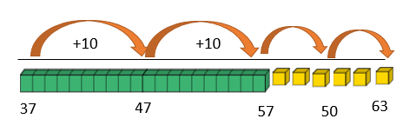  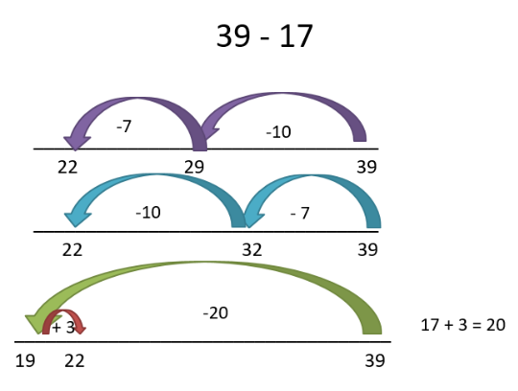  26 = 20 + 3 + 3  Recognising where to split the ones to hit the multiple of 10  Use dienes along ENL to show link with columnar PV  37 + 26  Make sure children use the ENL – counting back for subtraction and forwards for addition  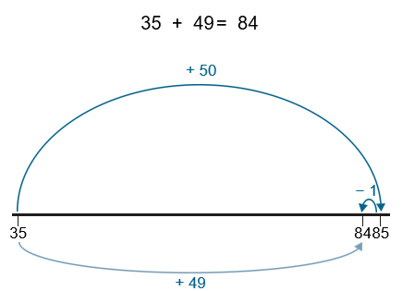  63  37 26  Adjusting with addition – take from one side add to the other  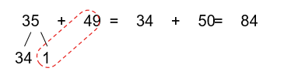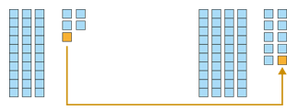  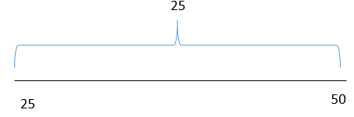  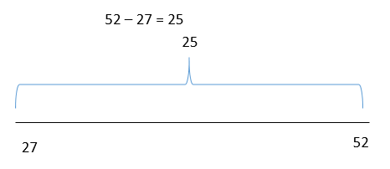  Adjusting with subtraction is same difference. Subtract 2 from each side 52 -27 is the same as 50 -25 both equal 25.
Recognise when finding the difference would be a more efficient strategy when subtracting NCETM 1.12 1.19 | 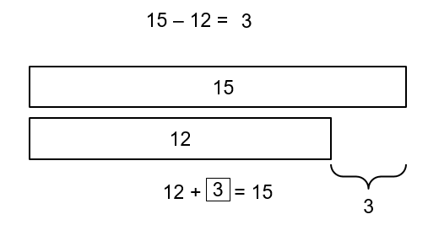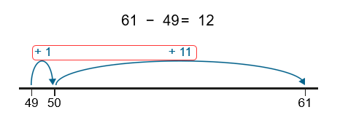
Recognise near doubles in calculations | 6 + 7 = 6 + 6 + 1 13 + 15 = 14 + 14
Autumn 2 | Multiplication and Division
Notes | Children should already have practised and reviewed their Y2 times tables 2s , 5s and 10s in separate sessions and be fluent on them.
By the end of the teaching sequence children should… | Examples and models and images to use
Have been exposed to all the key concepts of multiplication which will be constantly referred to throughout the school. Most of these are detailed below or in the Spring Term as they are new or relatively new learning from KS1. By reviewing using NCETM Year 2 PD materials you should cover most things. | Key concepts:  Understand the concept of multiplying by 1 and by 0  Understand the concept of dividing by 1 and itself  Use fact triangles to make multiplication and division fact families and extended fact families  Understand multiplication as repeated addition  Understand multiplication and division as an array  Use the distributive law to make calculations easier 7 x 8 can be 5 x 8 + 2 x 8 (use arrays)NCETM 2.10  Understand that multiplication is commutative but division isn’t  Make links with doubling and halving (in Y3 and Y4 through links with 4 x and 8x and 3x and 6x and in UKS2 doubling and halving factors)  Be able to discuss which methods are efficient and error proof or error prone.  Be able to multiply 3 numbers  Use multiplication in the context of scaling ( 3 times as many, 10 times bigger problems )  Vocabulary:  Use group size and number of groups 3 , 4 times  Use the language of dividend ÷ divisor = quotient factor x factor = product  Understand and use the word multiple  Understand and use multiply, divide, groups of, lots of, grouping and sharing (quotitive and partitive division)  Use unitising language 30 x 4 3 tens, 4 times
Know the multiplication and division facts for 2s 5s and 10s see NCETM Year 2 PD materials
Know multiplication and division facts for 3s 4s and 8 s
See NCETM Y3 and WR for activities to reinforce facts and teach the key concepts above.
Understand the symbols x ÷ and = and the language of factor and product NCETM 2.3 | 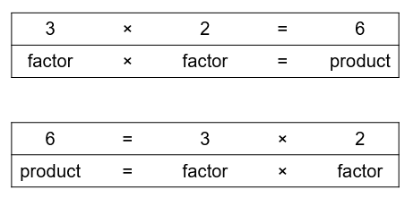
Can link the 10 x table with place value NCETM 2.4 | 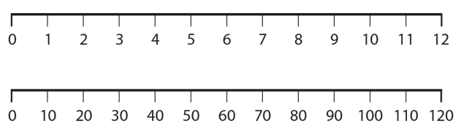
5 x table with markings on a clock face NCETM 2.4 | 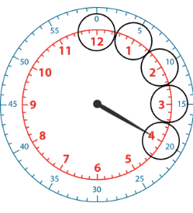  5 x 4 = 20  20 past  Use as an opportunity to review time from Y2
Link 2s , 5s , 10s times tables to money NCETM 2.4 | 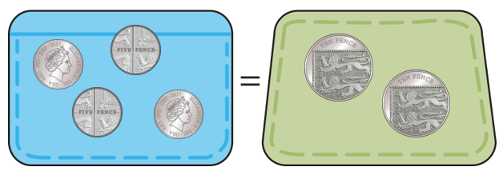  5p x 4 = 10p x 2
Know that multiplication can be expressed as repeated addition NCETM 2 .2 | 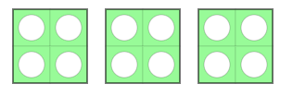  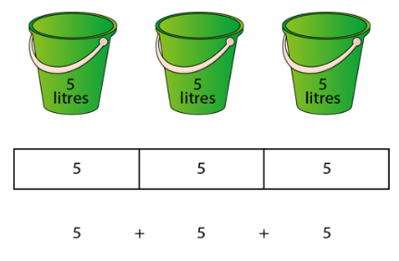  4 + 4 + 4 = 4 x 3 = 12  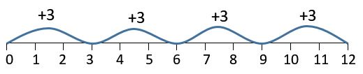  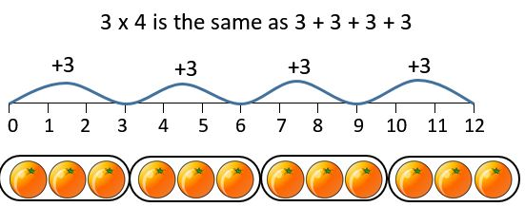  Use counters and cuisenaire rods alongside the numberline and/or bar model which can then be turned into an array.
Can express multiplication and division as an array and recognise that they can be read both ways. Remember group size and number of groups. | 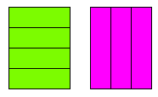  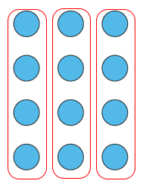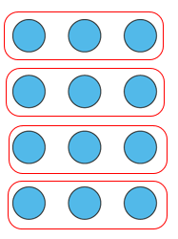  3 x 4 = 12  12 ÷ 4 = 3  4 x 3 = 12  12 ÷ 3 = 4
Understand multiplication as group size x number groups  NCETM 2 .2 (be careful with some images) Know that the group size and number of groups are both factors and they can be swapped (commutative law) | 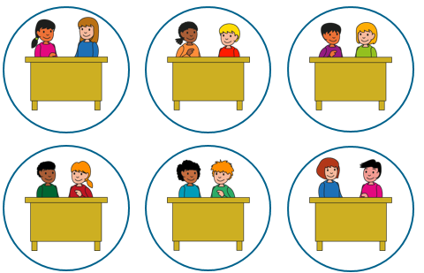  Group size 2  Number of groups 6  2, 6 times 2 x 6  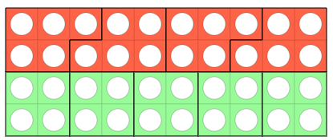  5 , 4 times 5 x 4  4, 5 times 4 x 5
Can show multiplication and division fact families | 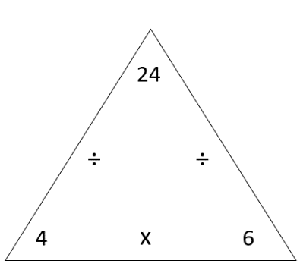  24 ÷ 4 = 6 24 ÷ 6 = 4  6 x 4 = 24 4 x 6 = 24
Express multiplication and division as a bar model | 24  4 4 4 4 4 4  6 x 4 = 24 24 ÷ 4 = 6  4 x 6 = 24 24 ÷ 6 = 4  24  6 6 6 6
Understand the concept of multiplying by 1 and by 0  NCETM 2.2 | 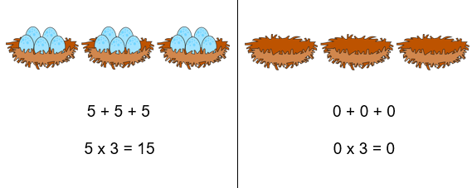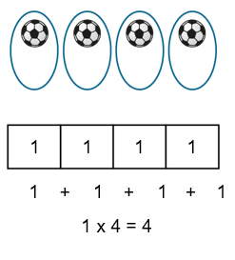
Know that multiplication is commutative and division is not | 24 ÷ 4 is possible but not 4 ÷ 24 use counters or sweets to demonstrate
Understand what a multiple is and when you are skip counting you are counting in multiples | 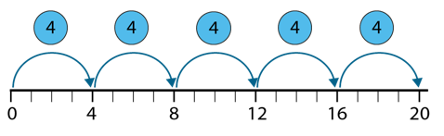
Add to the create the next multiple and this can be used to make calculations easier NCETM 2.10 and 2.7 | 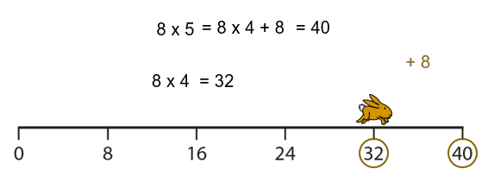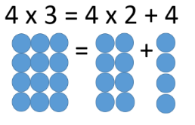
Subtract to the create the previous multiple and this can be used to make calculations easier NCETM 2.10 and 2.7 | 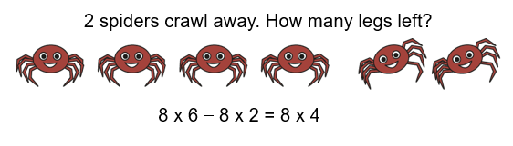
Know that doubling is the same as multiplying by 2
Know that halving is the same as dividing by 2 NCETM 2.6 | 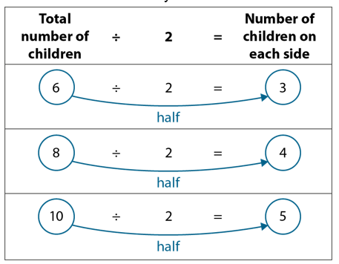
Link 4s and 2s and 8s by doubling and halving NCETM 2.7 | 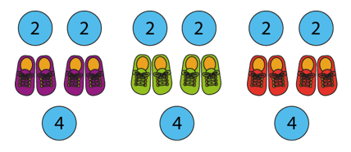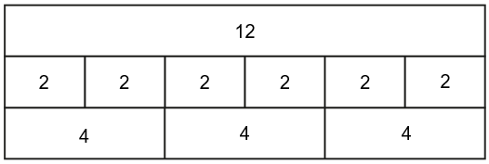  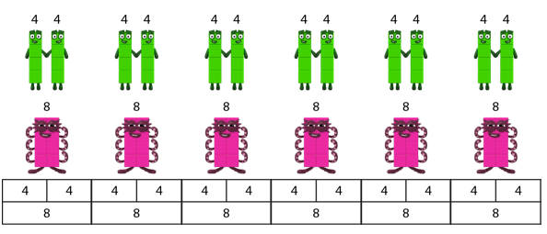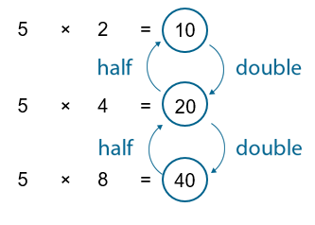  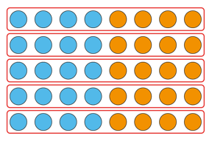
Know doubles and halves to 50
Know that division can be expressed as grouping and sharing NCETM 2.6 | 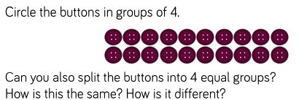  Image from WR Y3 use concrete apparatus to make groups of and share out.
Understand the concept of dividing by 1 and itself
Be familiar with the language dividend ÷ divisor = quotient NCETM 2.6 | 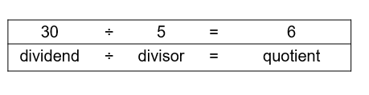
Know the divisibility rules for 2s 4s and 8s NCETM 2.7 | 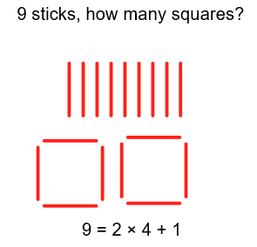  Investigate with concrete materials – leads on to remainders next term.
 | Fractions of amount
Teaching Points | Examples and models and images to use | Notes
A fraction is a whole divided into equal parts | See Summer 1 – what is and what isn’t a fraction. | It is important here that the children notice the link between fractions and multiplication and division. Using the array is the most effective here.
Be familiar with the vocabulary of numerator and denominator
¼ of 16 can be found by 16 ÷ 4
1/8 of 16 can be found by 16 ÷ 8
½ of 16 can be found by 16 ÷ 2
Represent fractions of an amount with a bar model | 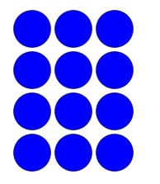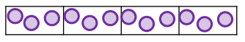  Array into a bar model then to just a bar model  12  3 3 3 3

