Summer 1 | Y3 Fractions
Notes | It is very important that all fraction work is done with concrete apparatus as well as diagrams and images.
By the end of the teaching sequence children should… | Examples and models and images to use
Understand fractions as equal parts of a whole NCETM 3.1 | 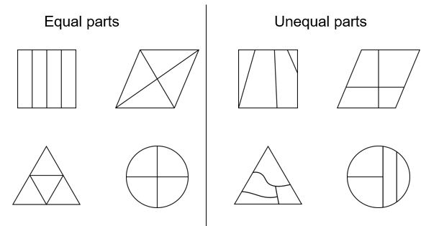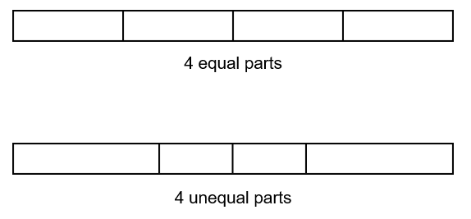  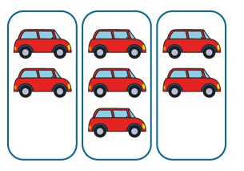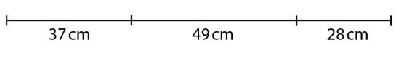
Be able to construct and interpret unit fraction NCETM 3.2 | 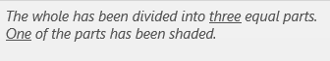  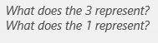  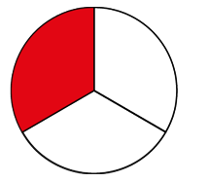
Understand the language of numerator and denominator  NCETM 3.2 | 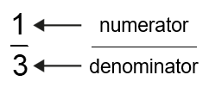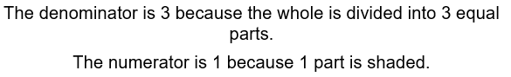
Be able to construct and interpret unit fraction NCETM 3.2 in different contexts | 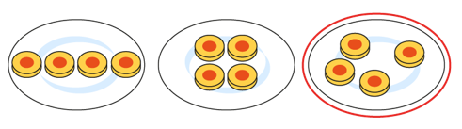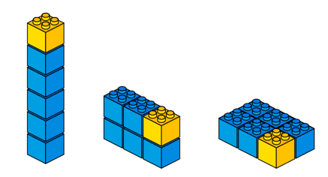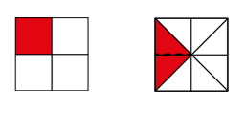
Review unit fractions of quantity | 12  3 3 3 3  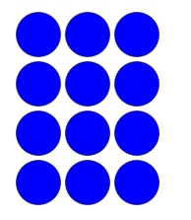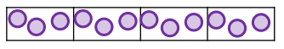  Array into a bar model then to just a bar model
Be able to construct and interpret non- unit fractions NCETM 3.3 | 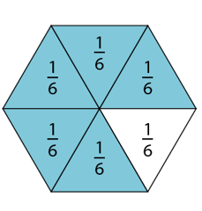  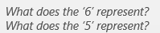  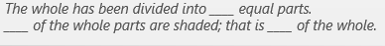
Know that when the numerator and denominator are the same then this is a whole. That when you have all the parts you have the whole. NCETM 3.3 | 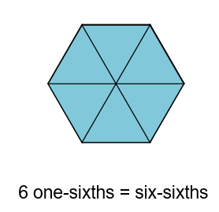
Be able to construct and interpret non- unit fractions in different contexts NCETM 3.3 | 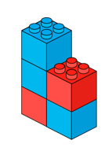 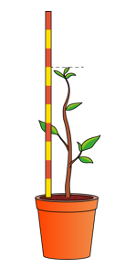 using measure and objects
Count in fractions and plot them on a number line NCETM 3.3 | 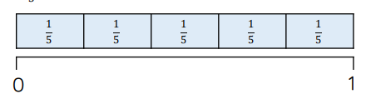  Fold up pieces of paper then draw a number line.  Also shows repeated addition which links to multiplication  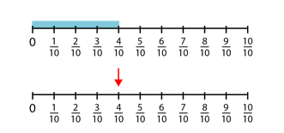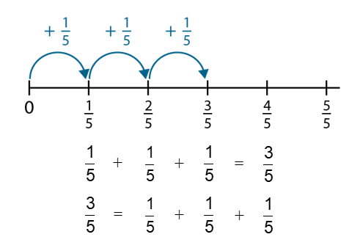
Compare and order unit fractions with different denominators and understand that the greater the denominator the smaller the equal parts and the smaller the fraction. | 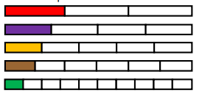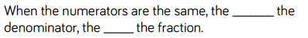  Use strips of paper to make the fractions and then compare using < > and = (equivalent fractions will be taught in detail in Y4  Use Cuisenaire rods
Compare and order non- unit fractions with the same denominator and understand that the greater the numerator the greater the fraction | 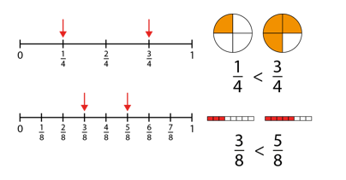
Find non-unit fractions of an amount | 12  3 3 3 3  9  ¾ of 12 is 9  Array into a bar model then to just a bar model
Add and subtract fractions with the same denominator within the whole | 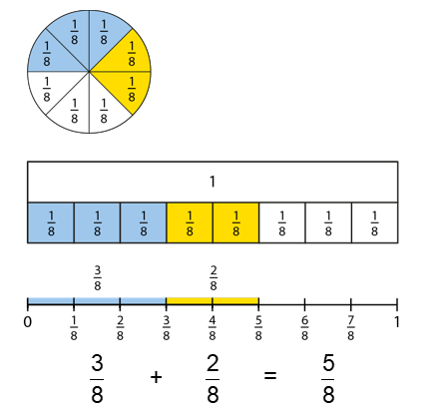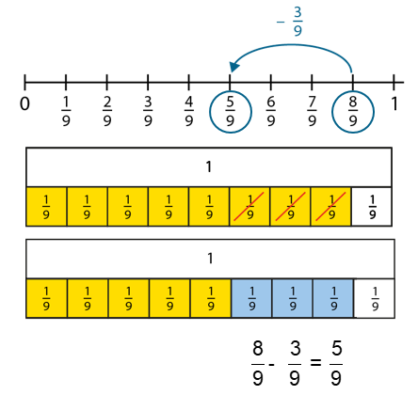  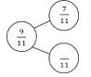  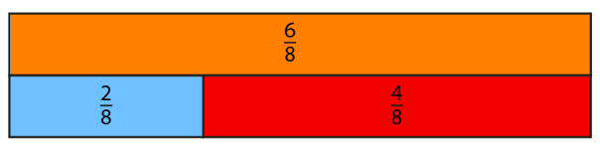  Use part whole model as in whole number addition and subtraction and write 4 calculations
Count in tenths and show as an image, word, fraction and a decimal | Moved to Y4
Show equivalent fractions making links with timetable knowledge | Moved to Y4
Summer 1 put end of autumn | Y3 Statistics
Teaching Points | Examples and models and images to use | Notes
Interpret and show data on pictograms, barcharts and tables |  | Link to fractions with pictograms – half an image
Know how to answer one / two step problems | Misconceptions on interpreting the axis and pictures on a pictogram
Summer 2 | Y3 Measure and Shape
Notes | With all of the next units they should be used to revise fractions, ENL strategies and times tables. Links are noted where applicable and all of the above should be ‘kept on the boil’ through number talks. Decimal notation is not used until Y4. Where possible use concrete apparatus – use rulers, scales, measuring jugs and let children play with the concepts.  Children should be exposed to word problems- White Rose is very good for this and can be used to review ENL this year and at the beginning of Y4
Teaching Points | Examples and models and images to use
Know how to use a ruler and know what mm, cm and m are. | 1 m 53 = 153 cm 60 mm = 6 cm  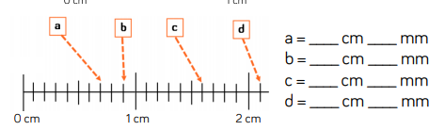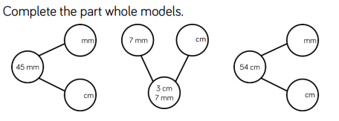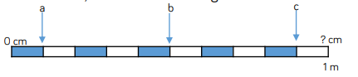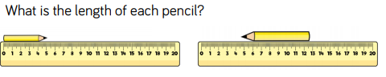
Convert between different lengths
Compare and order different lengths
Add/subtract lengths | 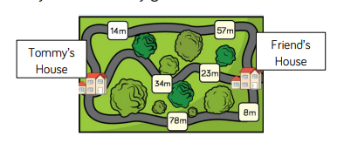
Identify and draw accurately 2D shapes | 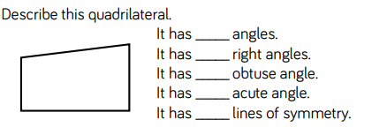  Children should have knowledge of 2D shapes from Y2 but a full review will be needed first.
Measure 2D shapes accurately
Find the perimeter of 2D shapes | 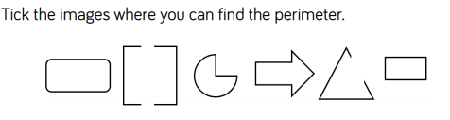  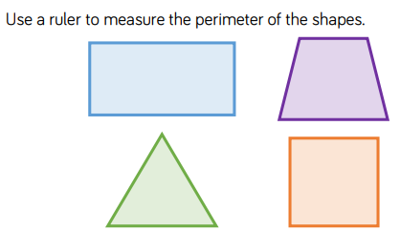  This is a new and important context – again let the children play by measuring. Can they figure out an easier way to find the perimeter?  Move on to calculating perimeter – can the children notice what happens with squares?  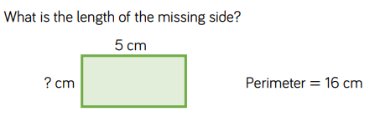
Identify 3D shapes | 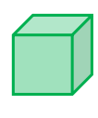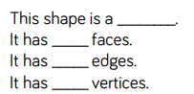
Understand g and Kg and when they are used | 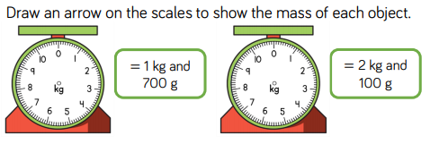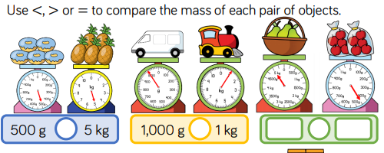  Do all of this with real objects and real scales  Children need to know there are 1000g in 1 Kg  Also talk about ½ kg = 500g 1 ½ kg 1 kg 500g  No decimal notation  Different increments should be used
Convert between g and kg
Compare g and kg
Understand ml and l and when they are used | 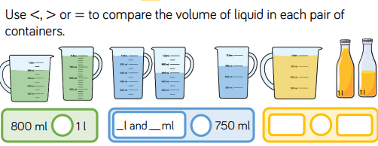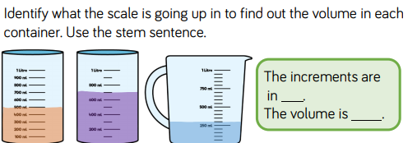  Do all of this with and water and jugs. Juice/milk containers  Children need to know there are 1000ml in 1 litre  Also talk about ½ litre = 500ml 1 ½ litres 1 l 500 ml  No decimal notation  Different increments should be used
Convert between ml and l
Compare l and ml
Add/subtract using l and ml and g and kg
Fraction of an amount problems – WR Y3 fractions Spring
Be able to tell the time on an analogue and digital clock |  | This should be continuous provision and should not need to be taught in a ‘lesson’
Know how many minutes in an hour/ seconds in a minute
Know how many hours in day/2 days months in a year
Find the duration of activities | Use ENL strategies
Know different types of angles | Also use N S E W and use ½ ¼ and ¾ turns  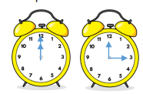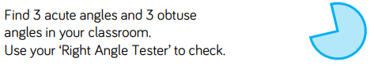
Compare different types of angles
Identify horizontal, vertical and perpendicular lines | 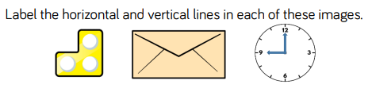  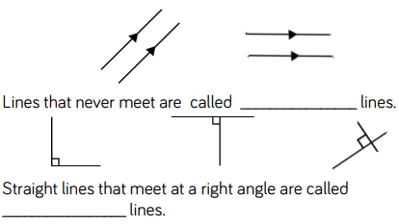
Draw accurately horizontal, vertical and perpendicular lines
Summer 2 | Y3 Money
Teaching Points | Examples and models and images to use | Notes
Recognise all UK coins and notes | Use real money/ practise money where possible to compare and convert  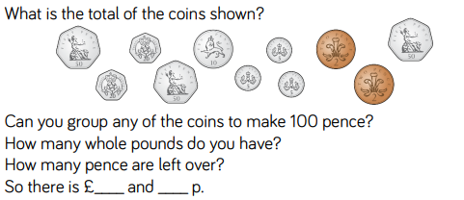 | Should already be familiar with this from the Autumn term and Y2
Know how many pence in the pound |  | Link to PV
Know how many 5ps 10ps 20ps and 50ps in a pound |  | Link to multiples and times tables and fractions
Convert from pounds to pence |  | Not using decimals
Add/subtract pounds and pence using ENL strategies | 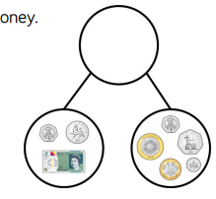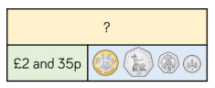  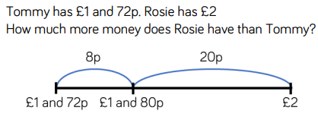 | Reminder of things like finding the difference which may be more efficient  Also use part whole models to draw links with addition and subtraction
Be able to give change | 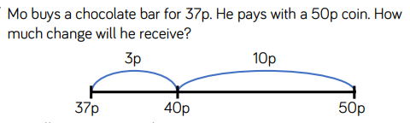 | 2 step problems – add 2/3 items then calculate change
Be able to solve a variety of 1 step and 2 step problems using shape, measure, time, money, fractions and the 4 operations. | See White Rose SOL and problems of the day.  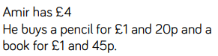  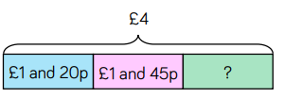 | Use bar modelling to help

