Spring 1 | Y5 Multiplication and Division written methods
Notes: children should be competent with the area model from Y4 so should be an easy step on to 2d by 2d. No larger numbers should be used with the area model as it is not efficient. Unitising language should be used – one ten multiplied by two tens equals two tens as per key concepts.
By the end of the teaching sequence children should… | Examples and models and images to use
Multiply 3d by 1 d using the area model (reviewed from Y4) and formal method. | 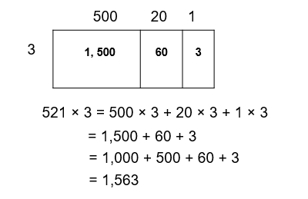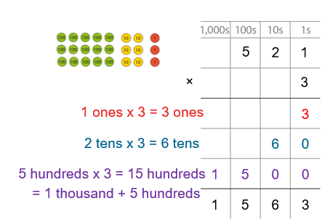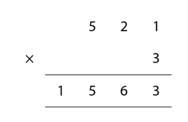
Multiply 2 d by 2d with the area model using PV counters and Cuisenaire rods See NCETM 2.23 | 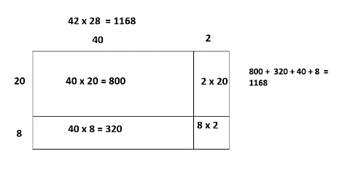  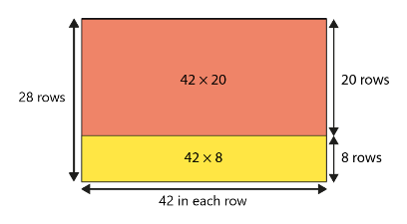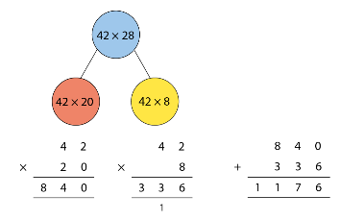
Multiply 2 d by 2d with long multiplication | See NCETM 2.23. Use expanded first then abstract algorithm.  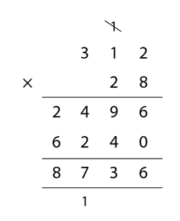  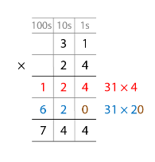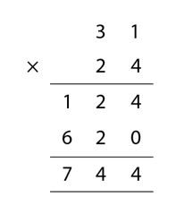  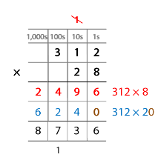
Multiply 3 d by 2d with long multiplication
Multiply 4 d by 2d with long multiplication
Divide 3d by 1d using short division and PV counters NCETM 2.15 | 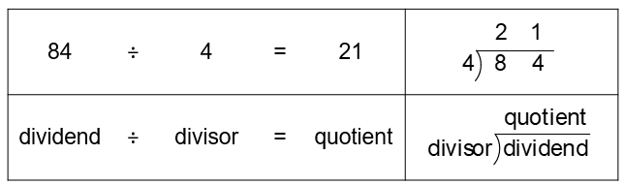  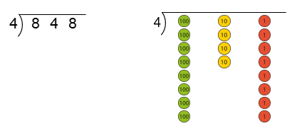  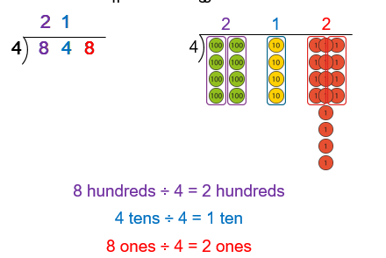  2
Divide 3d by 1d using short division
Divide 4d by 1d using short division
Interpret remainders (round up or round down according the question)
Solve mixed operation problems |  | Also with Spring 2
Spring 2 | Y5 Decimals and Fractions
Notes: Not necessary to do any rounding or PV to 3 dp as that can be covered in Y6. Use context of measure and money (see WR Maths ) to give a real life context and review learning from Y3 and Y4 on measurement. NCETM 3.10 WRMaths
By the end of the teaching sequence children should… | Examples and models and images to use
Understand the concept of tenths, hundredths and thousandths that there are 10 tenths in a whole, 10 hundredths in a tenth and 100 hundredths a whole | 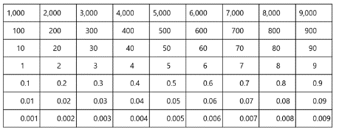  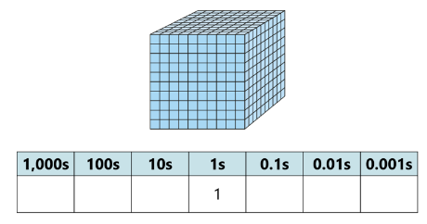  1000 square  As 1 whole  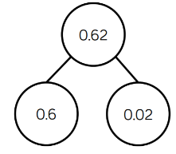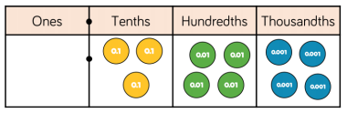
Represent decimals in a place value chart
Represent decimals as fractions
Partition decimals and fraction equivalent according PV
6 . 24 6 + 0.2+ 0.04 6 + 2/10 + 4/100
Partition decimals and fraction equivalent a variety of ways 6.24 62 tenths and 4 hundredths 6 + 24/100
Read and write decimal numbers as numerals and fractions 0.71 71/100 | 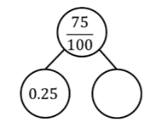  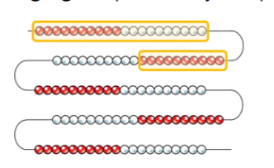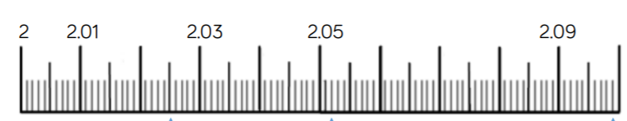  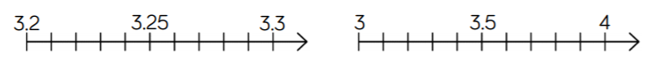  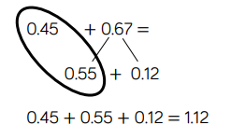  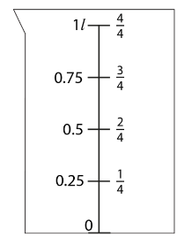  Note: these are images only – please check that calculations are suitable for formal methods.  Using complements to 1  A number line but just the other way round  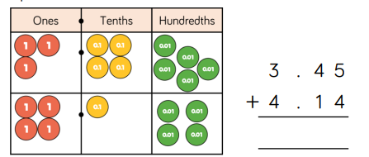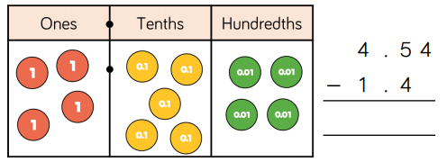
Count in decimals and place decimals to 1 dp on a number line
Count in decimals and place decimals to 2 dp on a number line
Compare decimal numbers to 2 dp
Round decimals to the nearest whole on a number line
Round decimals to the 1 dp on a number line
X and ÷ decimal numbers by 10, 100, 1000
Convert between units of measurements: Review fractions 1 ½ km
Add and subtract decimals using ENL strategies and formal methods (use PV counters and dienes first).

