Summer 1 | Y5 Fractions, Decimals and percentages
Notes: Review fraction objectives from Y4 – these should be kept on the boil See Y4 Spring 2
By the end of the teaching sequence children should… | Examples and models and images to use NCETM 3.7 and 3.10 plus White Rose
Write, identify and represent visually equivalent fractions | 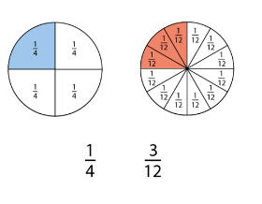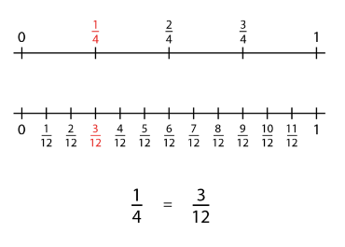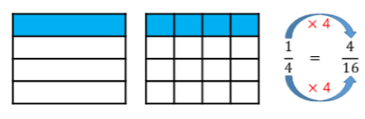
Convert from mixed to improper fractions and back again | 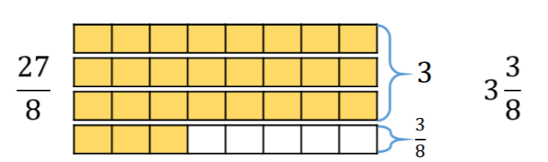
Compare and order fractions whose denominators are multiples of the same number  Compare using numerator and denominator | 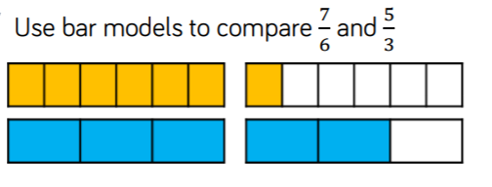
Add and subtract fractions whose denominators are multiples of the same number. Review adding and subtracting fractions with the same denominator from Y4. | 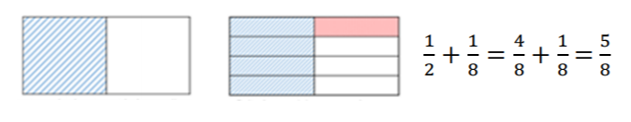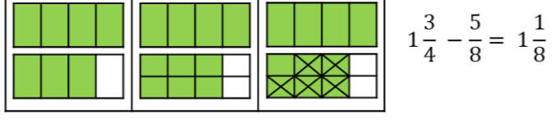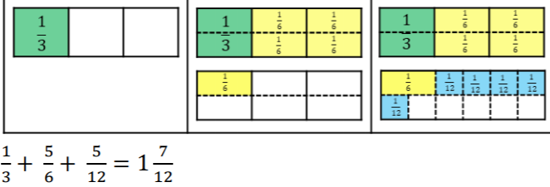
Understand that percent means part of 100  NCETM 3.10 | 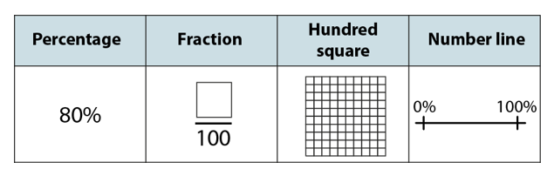  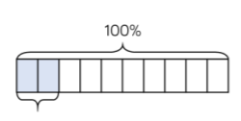  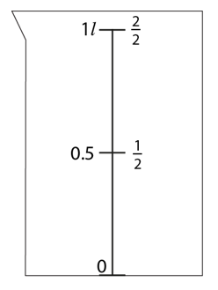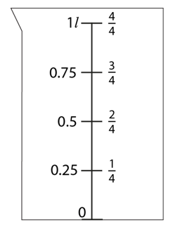  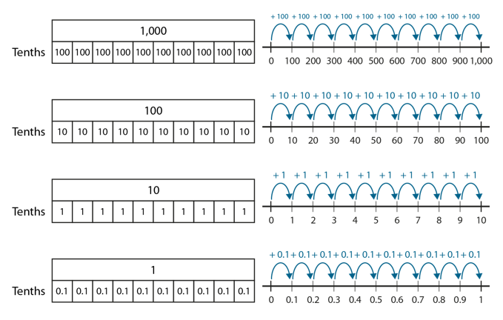  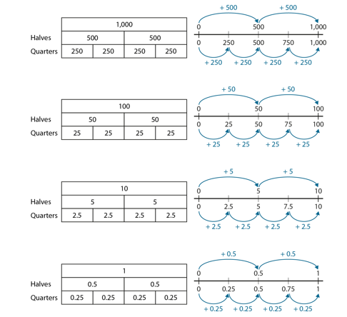  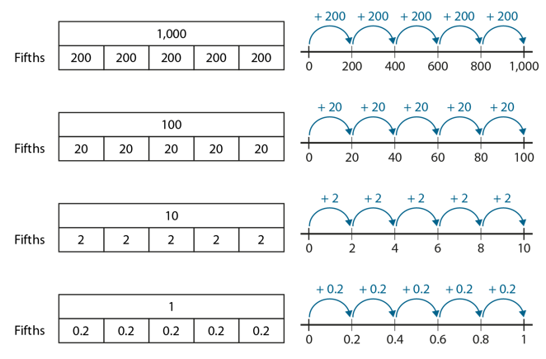
Visually represent percentages
Link percent with tenths and hundredths
Write percentages as fractions and decimals
Write tenths as fractions , decimals, words and images
Know the decimal and percentage equivalents of ¼ ½ 1/5 and non-unit fractions of these denominators
Know the percentage and decimal equivalents of fractions that have a denominator with a multiple of 10 or 25
Summer 2 | Y5 Shape and position
Notes: use this opportunity to review measure, squares numbers and fractions. Also review efficient methods of calculating.
By the end of the teaching sequence children should… | Examples and models and images to use
Identify and draw 2D shapes | 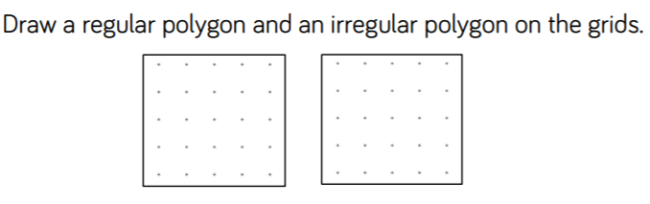
Understand regular and irregular shapes | 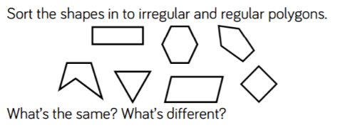
Identify and draw quadrilaterals
Measure and calculate the perimeter of rectilinear shapes
Measure and calculate the perimeter of composite rectilinear shapes | 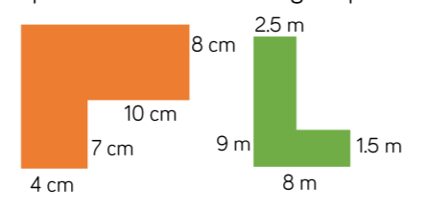
Calculate and compare areas of rectangles including squares | 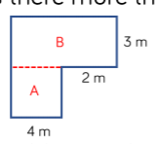
Estimate the area of irregular shapes | 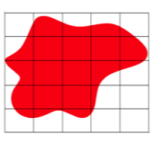
Identify 3d shapes | 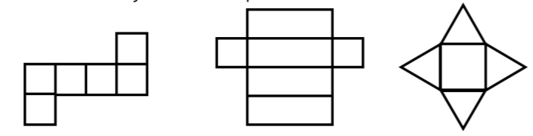
Estimate volume (using cubes and cuboids) and capacity | 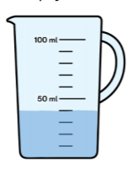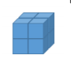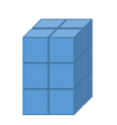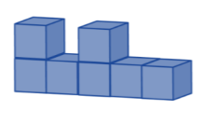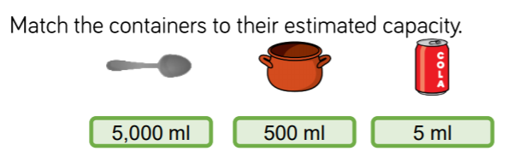
Draw and measure angles in degrees | 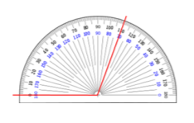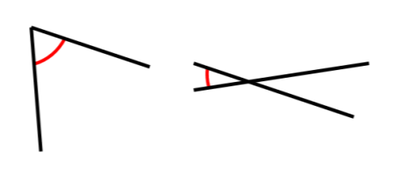
Be able to use a protractor accurately
Order and compare angles | 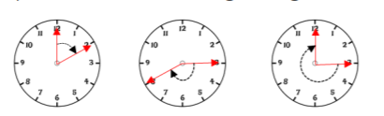
½ turn = 180 1 ½ turns etc full turn – 360 use multiples of 90 | 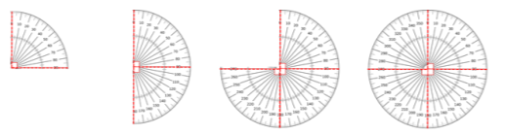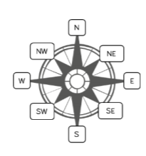
Calculate missing angles on a straight line and round a point | 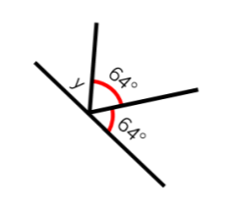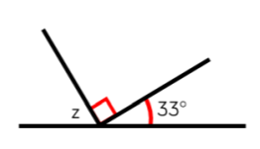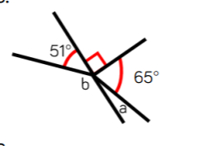
Plot and draw shapes on a co-ordinates grid
Translate shapes on a co-ordinates grid

