Autumn 1 | Y3 Place Value and ENL strategies
Notes | Recall facts document should also be used as continuous provision/ assessment to check children are secure on Y3 objectives. Previous CT should have noted any gaps on previous recall facts document. See Y3 Spring 1
Autumn 1 | Y4 Place Value
Notes | Roman Numerals should be taught as continuous provision as should time. Use the language of unitising for example 70 is 7 tens 170 is one hundred and 7 tens and also 17 tens
By the end of the teaching sequence children should… | Examples and models and images to use
Key concepts for Place Value
All place value should be taught through the following for the applicable numbers:
PV chart with dienes and from Y4 PV counters and dienes
Children should show a number with dienes and from Y4 PV counters and dienes
Show numbers on an ENL and a demarcated number line
Show numbers on a gattengno chart
Partition numbers by place value
Partition numbers in a variety of ways
Show partitioning with part whole models (bar and circle)
Order and compare numbers using images and a number line and verbal reasoning
Read and write numbers
Know there are 10 thousands in 10,000 and 100 hundreds in 10,000 | 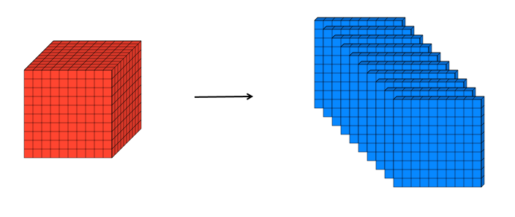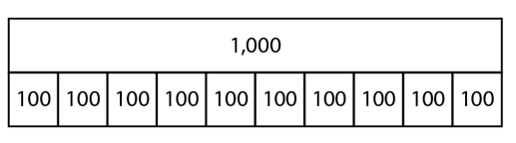
Count in 1000s to 10,000 | 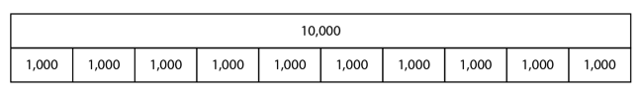
Represent 4 digit numbers to 10,000 | 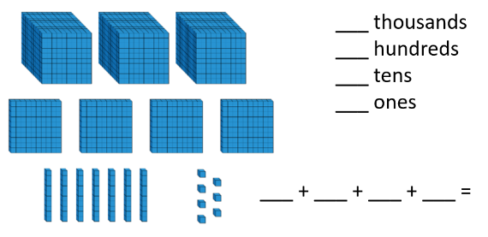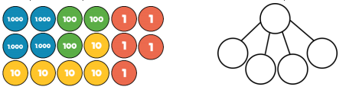
Partition 4 digit numbers to 10,000 in a PV chart | 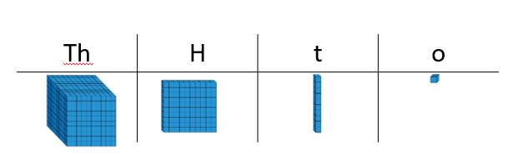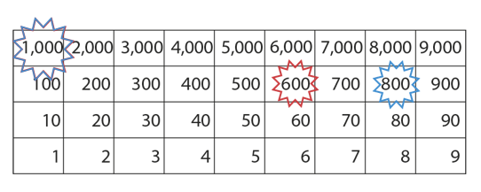
Partition 4 digit numbers to 10,000 in a variety of ways | 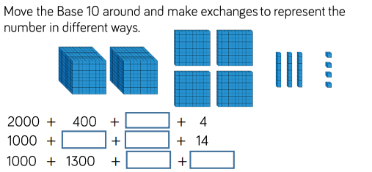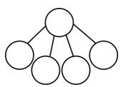  Also partition with a part whole model
Order 4 digit numbers to 10,000
Read and write 4 digit numbers to 10,000
Count in and recognise multiples of 25 | 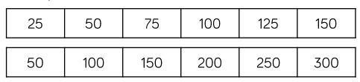  Link to fractions of an amount – quarters. Know that there are 4 25s in 100 so 4 250s in 1000.
Place any number to 10,000 on a numberline with 1000s | 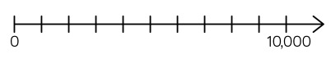
Place any number to 10,000 on an ENL | 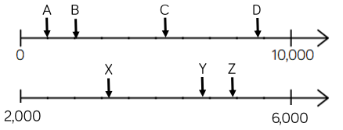
Know the next and previous multiple of 1000 and 100 NCETM 1.22 | 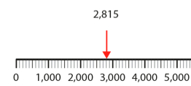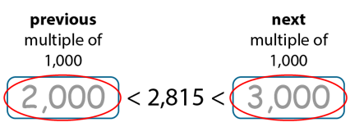  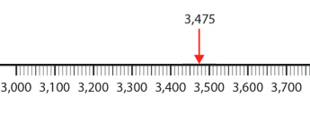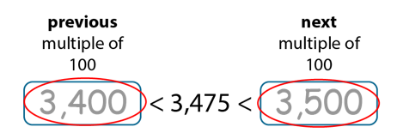
Know 1000 more/less than any number to 10,000 | 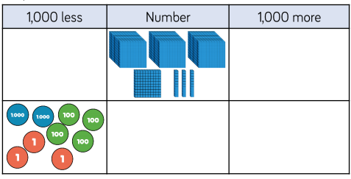  Use concrete apparatus to add and subtract 1000. Also show on ENL. What do they notice? Only 1000s change.
Compare numbers to 10,000 using < > = | 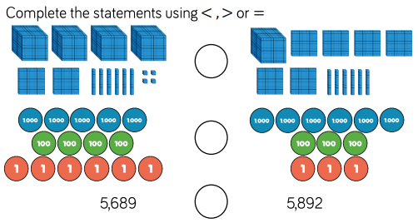
Show on a number line the nearest 10, 100, 1000 | 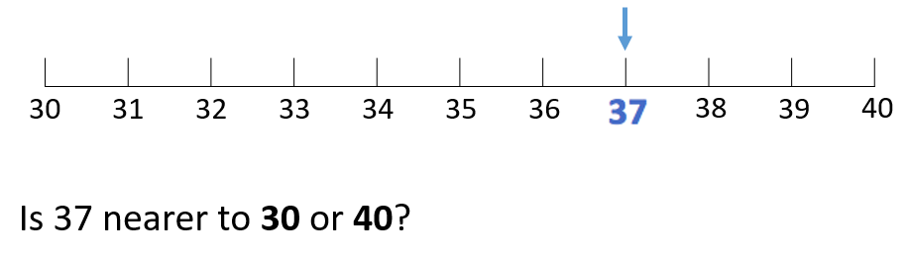  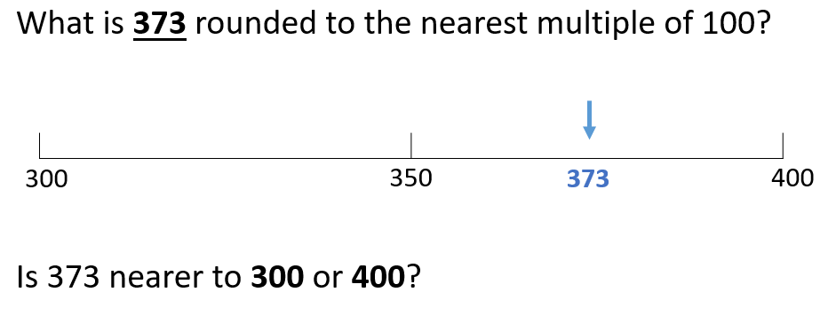
Round any number to the nearest 10/ 100/1000
Be able to show negative numbers on a numberline | 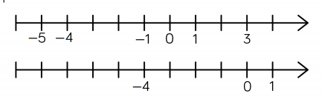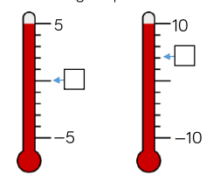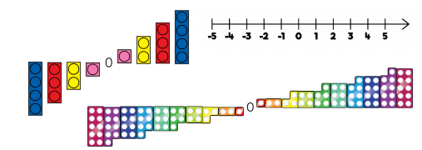  Use everyday contexts such as temperature and water depths.
Count forward and back through 0 using negative numbers
Autumn 1 | Y4 Addition and Subtraction ENL and mental strategies
Notes | Key concepts  Use unitising language such as 5 tens subtract 3 tens equals 2 tens, three hundreds add 4 hundreds equals 7 hundreds.  Identifying no work, mental and jottings calculations should be part of continuous provision and once children are secure with written methods always provide calculations that don’t need a formal method. Empty box calculations, moving the equals sign and balancing equations should also be part of continuous practise and number talk.  Children should estimate their answer first  Multi step problems should be included including multiplication and division  Include problems with money and measure (keep previous year group objectives on the boil) and statistics (this block can be included with addition and subtraction)  ENL strategies should be used with time and can be practised with money and measure as well  Children should be able to adjust calculations to make them easier  Know that addition is commutative and subtraction is not  Be able to use the inverse to check (part whole models)  Vocabulary: sum, total, difference, total, altogether, how many more, how much less
By the end of the teaching sequence children should… | Examples and models and images to use
Have reviewed all of the ENL strategies from Y3 up to 3d
Add and subtract multiples of 100 and 1000 | 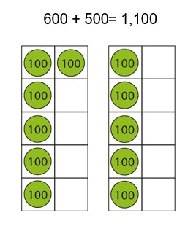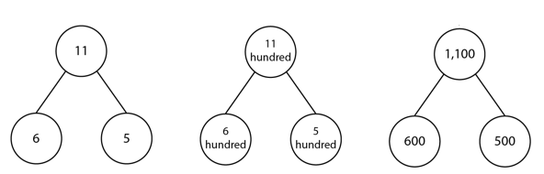  use the same image but for multiples of 1000  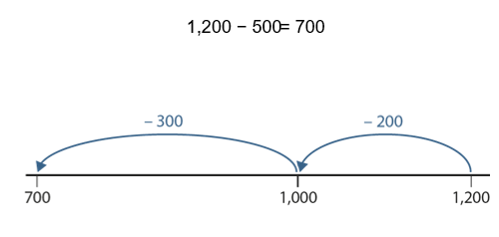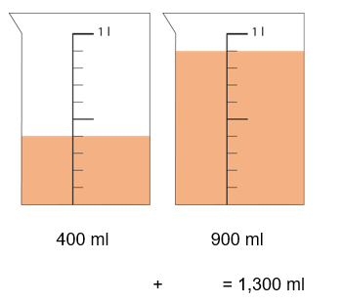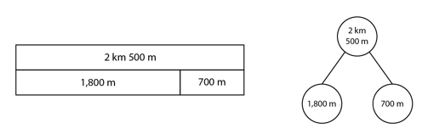
Add/subtract 1s 10s 100s and 1000s from any number to 10, 000 | Use the context of measure to review concepts from Y3 and practise ENL strategies
Autumn 2 | Y4 Addition and Subtraction Written methods
Notes | Base 10 must be used first with expanded form by the side and abstract algorithm  PV counters can then be used once concept is secured with the abstract algorithm alongside
By the end of the teaching sequence children should… | Examples and models and images to use
Add 3d numbers using column addition with one exchange | 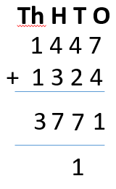  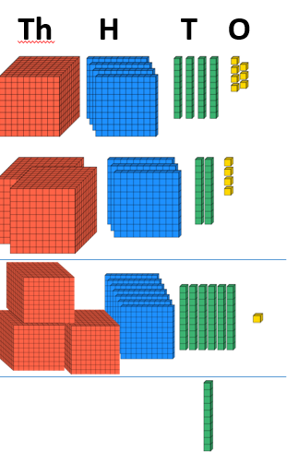  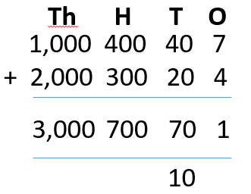  Eleven ones is exchanged for one ten and one one use PV counters once concept is secured.  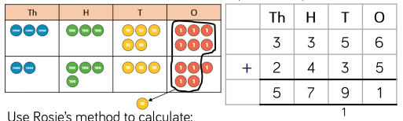
Add 3d numbers using column addition with more than one exchange
Add 4d numbers using column addition with one exchange
Add 4d numbers using column addition with more than one exchange
Subtract 3d numbers using column addition with one exchange | 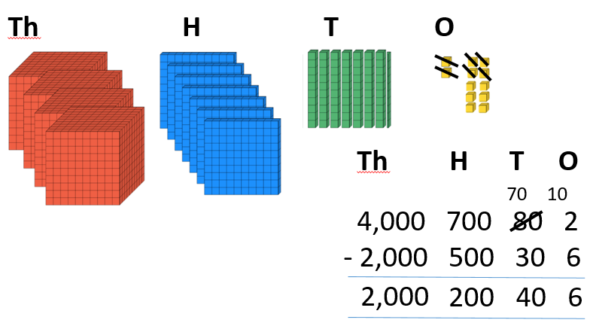  There is not enough ones to subtract 6 so exchange one ten for ten ones. Ten ones plus 2 ones is 12 ones. 12 ones subtract 6 ones is 6 ones. Now there is 7 tens not 8 tens. 7 tens subtract 3 tens is 4 tens etc.  Use PV counters once secure with the concept. Moving to abstract algorithm  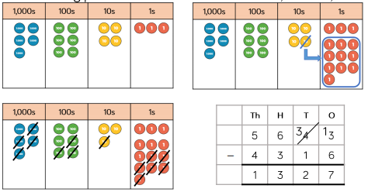
Subtract 3d numbers using column addition with more than one exchange
Subtract 4d numbers using column addition with one exchange
Subtract 4d numbers using column addition with more than one exchange
Use the inverse to check answers and show calculations as part – whole models | 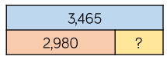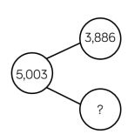  Also write 4 calculations that go with the part whole model
Be able to solve one step and two step problems in different contexts using addition and subtraction and apply the correct calculation method e.g measure and time reviewed from Y3 leading on to Y4 objectives below | 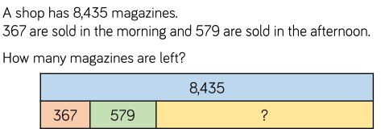
Y4 length and perimeter
By the end of the teaching sequence children should… | Examples and models and images to use | Notes
Know how many metres in a km |  | Use bar model to review number bonds to 1000
Convert between metres and kilometres
Add and subtract lengths |  | Review addition and subtraction strategies and fractions of amount in ½ km etc
Understand that perimeter means the outside of a 2D shape
Find the perimeter of rectilinear shapes

