Summer 1 | Y4 Decimals and Money
Notes | Concept of tenths is moved from Y3 to Y4 to fit with hundredths and money. Children should already however to familiar with money and calculating with money from Y3. Review of coins and pounds and pence may be needed and use concrete apparatus where possible to secure the concept.
By the end of the teaching sequence children should… | Examples and models and images to use
One tenth is a whole divided by 10 | 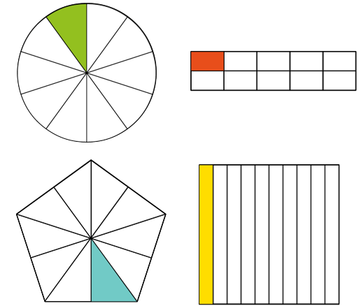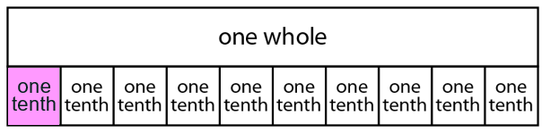
Write tenths as fractions , decimals, words and images | 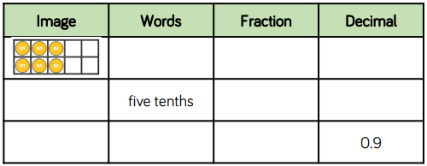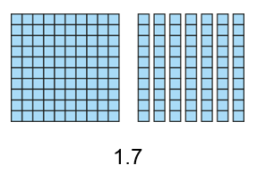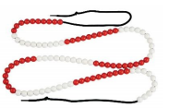  Base 10 one hundred block as one whole
Show tenths on a number line (as fractions and decimals) and count in tenths | 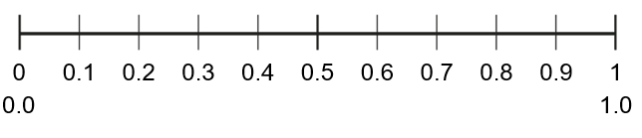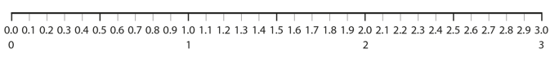
Show tenths on a PV chart | 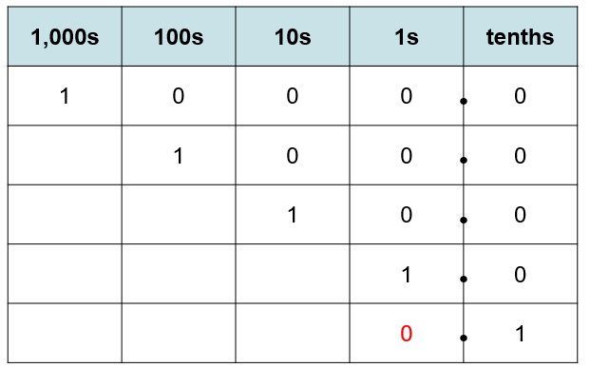  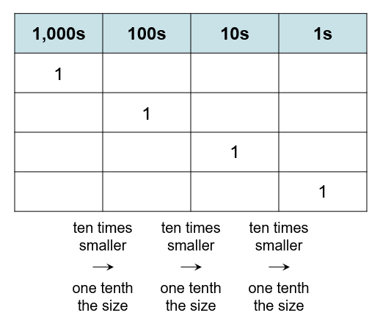  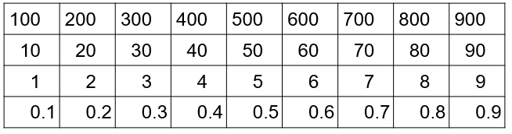
Partition tenths | 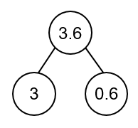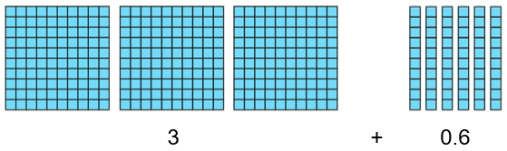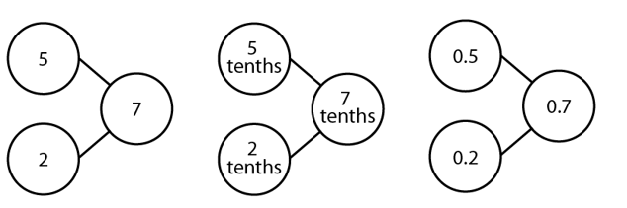
One hundredth is a whole divided by 100  Understand 10 hundredths is one tenth and you get hundredths by dividing tenths by 10 | 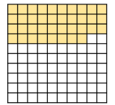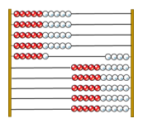  Show links with whole numbers – you could also use a tens frame here. Use unitising language - 36 tenths
Partition numbers into tenths and hundredths | 65/100 = 6 tenths and 5 hundredths or 6/10 and 5/100  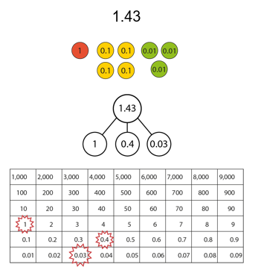
Partition decimals in a variety of ways | 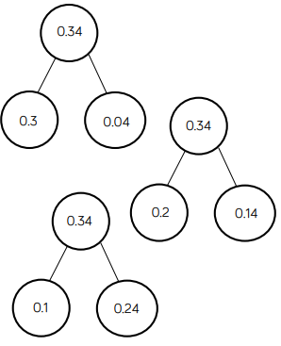  Use dienes and a bead string/bar to play around with this concept
Write hundredths as fractions , decimals, words and images | 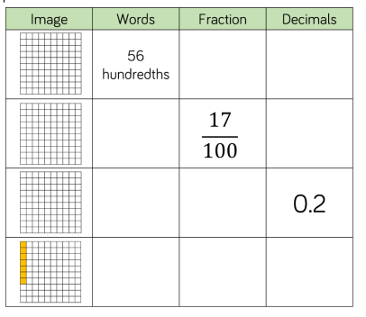
Show hundredths on a number line (as fractions and decimals) and count hundredths | 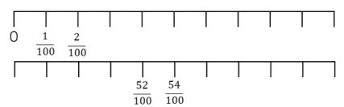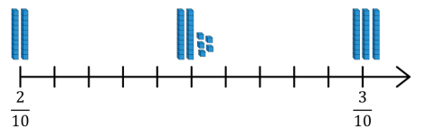
Show hundredths on a PV chart | 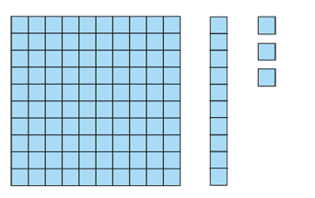  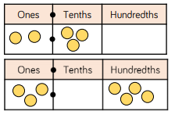  Use dienes first then can use PV counters or normal counters  Use unitising language 1.2 can be 12 tenths 1.13 can be 113 hundredths 0.23 can be 23 hundredths
Explain what happens when you divide a 1 or 2d number by 10 | 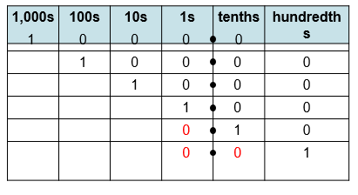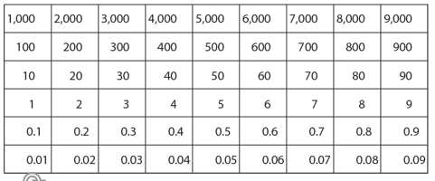  Use a PV chart with dienes and gattengno chart. Children should be familiar with this from the spring term and multiplying and dividing whole numbers by 10 and 100
Explain what happens when you divide a 1 or 2d number by 100
Compare and order decimals to 2dp by understanding the number of tenths and hundredths in a number | Do in all contexts including measure and money.
Understand tenths and hundredths in the context of measures. | 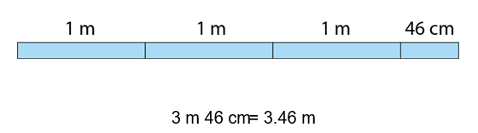  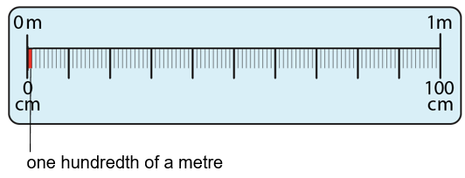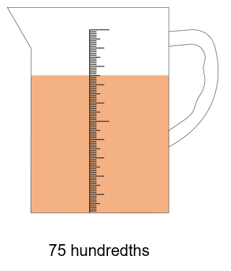
Understand hundredths and tenths in the context of money | Put pounds and pence in a PV grid
Covert pence into pounds and pence | 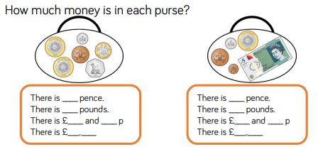  Use real money where can.  Moving on from Y3 money can now be written as decimals
Compare and order amounts of money | Use real money and contexts
Round money to the nearest pound | 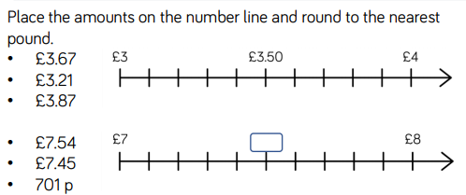
Round decimals to the nearest whole number | Use the same strategy as above with the number line – just take away the pound symbol
Review fractions by finding ½ a pound ¼ of a pound. Use this to introduce decimal equivalents to ½, ¼ and ¾ | 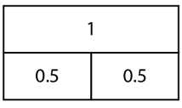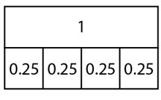
Summer 2 | Y4 Shape and position
Teaching Points | Examples and models and images to use | Notes
Identify and draw quadrilaterals | 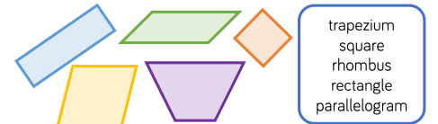
Find the area of rectilinear shapes by counting squares |  | Review perimeter at the same time
Identify and draw triangles | 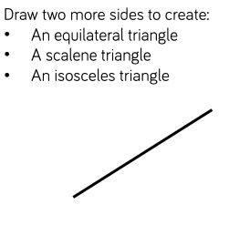
Identify and draw lines of symmetry in 2D shapes | 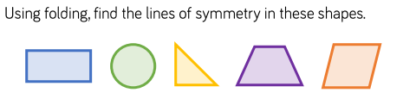  Use shapes cut up in bits of paper to fold  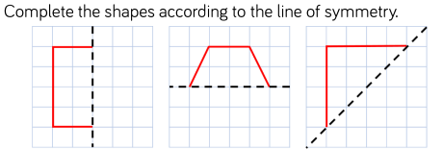 | Review 3d shapes (not a Y4 objective)
Classify 2D shapes
Understand co-ordinates in the first quadrant | 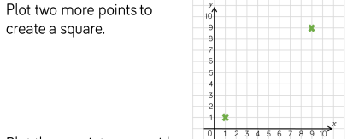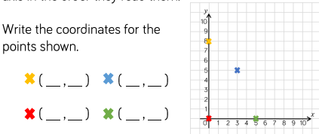
Plot 2D shapes in the first quadrant
Plot points in the first quadrant to complete a 2D shape
Identify and order angles | 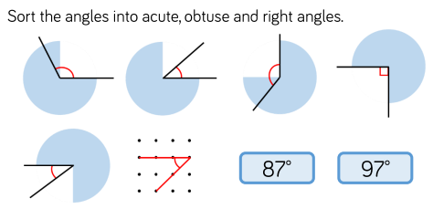 | Review angles and vocabulary from Y3 plus horizontal, vertical, perpendicular parallel as not Y4 objectives
Convert time from 12hr clock to 24 hr clock |  | This can be done as continuous provision as opposed to a discrete lesson
Convert hours, minutes, days, weeks, months , years |  | This can be done as continuous provision as opposed to a discrete lesson
Understand that discrete data can be represented as a bar chart or pictogram | 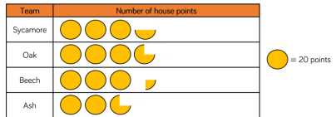 | Misconception here with pictograms – half and quarter symbols and what they represent
Solve comparison, sum and difference problems from bar charts or pictograms |  | Addition and subtraction methods can be used here particularly when using larger numbers such as attendance at a concert/match
Understand that continuous data such as time, temperature and height can be represented as a line graph | 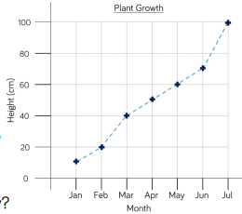 | Opportunity to review negative numbers as well as time and decimals/measures with height/weight  Misconception – reading a line graph. Children need to use a ruler to read the axis

